Athletic Science 10
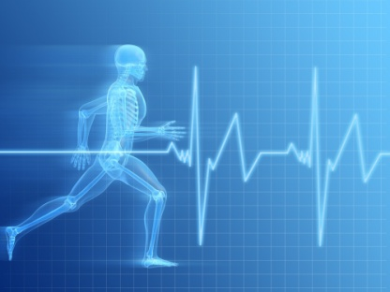
Course Outline
Mrs. Weber 2013
website: houseofweber.weebly.com
email: kateweber@gpcsd.ca
Course Description:
- Athletic Science is a cluster of courses that will help you develop a background and deepen your interests for athletics, health and wellbeing. You will cover three different modules. Each module will have various small projects, quizzes and assignments. Each module will finish with a major assignment or project.
Assessment and Evaluation:
Daily Assignments  - Small group work, research, readings, reflections, journals, etc. | 40%
Major assignments  - Presentations, research projects, etc. | 30%
Quizzes  - Practical lab quizzes as well as unit quizzes | 20%
Practical Labs  - Labs that require practical components such as taping, and physical labs. | 10%
Modules:
- Health and Wellness Fundamentals (pre-requisite)
- Musculoskeletal System
- Injury Management 1
** Each module completed will equal 1 credit earned for graduation. If a student fails to complete a module or get’s lower than 50% in that module, they will not receive a credit. **
Expectations:
It is expected that all students work their best ability at all times. This means being prepared for class with materials (paper, pens, binder, etc.), attending regularly and on time, as well as being respectful to their instructor. Handing in assignments on time is required. There will be consequences (homework room, ISS, and administrative intervention) if this policy is not adhered to.

I look forward to a great semester with you!
- Mrs. Weber

