Chapter 2: Identity and the Forces of Globalization
Inquiry Questions:
RI#1: To what extent should we embrace globalization?
1.What are some of the forces of globalization?
2.How is identity affected by some economic, political, environmental and social dimensions of globalization ?
3.How do some forces of globalization present challenges to identity?
4.How do some forces of globalization provide opportunities to affirm and promote identity?
Blog Response #1 & #2
World Cafe: The Banana Wars
Critical Challenge: Globish
Key Terms:
Transnational corporation Media concentration
Media convergence Economies of scale
Biodiversity Homogenization Acculturation
Accommodation Assimilation Cultural revitalization

John Green - Globalization 1 Youtube (watch this at least 5 times!)
Is it? (it’s a small world after all) - Song

GLOBAL shipped to LOCAL = “GLOCAL”

Draw and image/visual representation below that represents this idea....

- Globalization and Trade in Food
(snack intro)
Record all the food you have eaten in the last 24 hours. As best as you can, identify the country or province of origin of the food.
MEAL | FOOD | Place of Origin(s)...
Breakfast
Lunch
Dinner
Snacks

What impact does TRADE have on globalization?

Trade as a Globalization Force

People have always reached out to others to obtain things they cannot grow or make themselves. In North America, for example some areas of the eastern Arctic are rich in soapstone, but wood is scarce. So the Inuit of the Eastern Arctic reach out to other Aboriginal groups, who live farther south, and trade what they have for what they need.

Other examples of historical trade?

People trade with one another to obtain good sand services that are:
- Not in their own .
- Better or less .
- Different from produced at .

DEFINE “Transnational Corporation” below:

Discussion: How does the HBC --> Zellers ---> Target represent Transnational corporations?

Video: http://tinyurl.com/h6sxq2s

Transnational corporations play an important role in globalization process. Companies like McDonald's, Coca-Cola, and Nike sell fast food, soft drinks and shoes around the world. In many countries they provide training and jobs for people who might not otherwise have work.
However, critics of transnationals say that the jobs are often “McJobs”: Low-level positions that require little skill and provide few opportunities to advance. Another criticism, is that the profits from these products go back to the ‘home’ country and do not stay in the country of manufacturing. The profits do not benefit the people of the country where the goods are actually made or sold. Yet another criticism of TNCs is that the loose environmental restrictions in the countries where items are being produced result in health concerns and environmental degradation that is not policed or regulated.

BLOG Response #1 - Who should hold TNC accountable?
(Case Study: Monsanto)

Behind the Swoosh: Video
Catholic Social Justice and Nike
http://tinyurl.com/pnczd8n
Discussion:

CANADIAN AUTHOR (and a Weber favourite) Douglas Coupland did not coin the word McJob, but he made it popular in his book Generation X: Tales for an Accelerated Culture.

......find the Webster's dictionary definition for “McJob” and put it below....

Source Review: Can McDonald's Alter the Dictionary? - TIME
http://tinyurl.com/jc2vtsz
Response/Thoughts:

Transportation as a Globalization Force
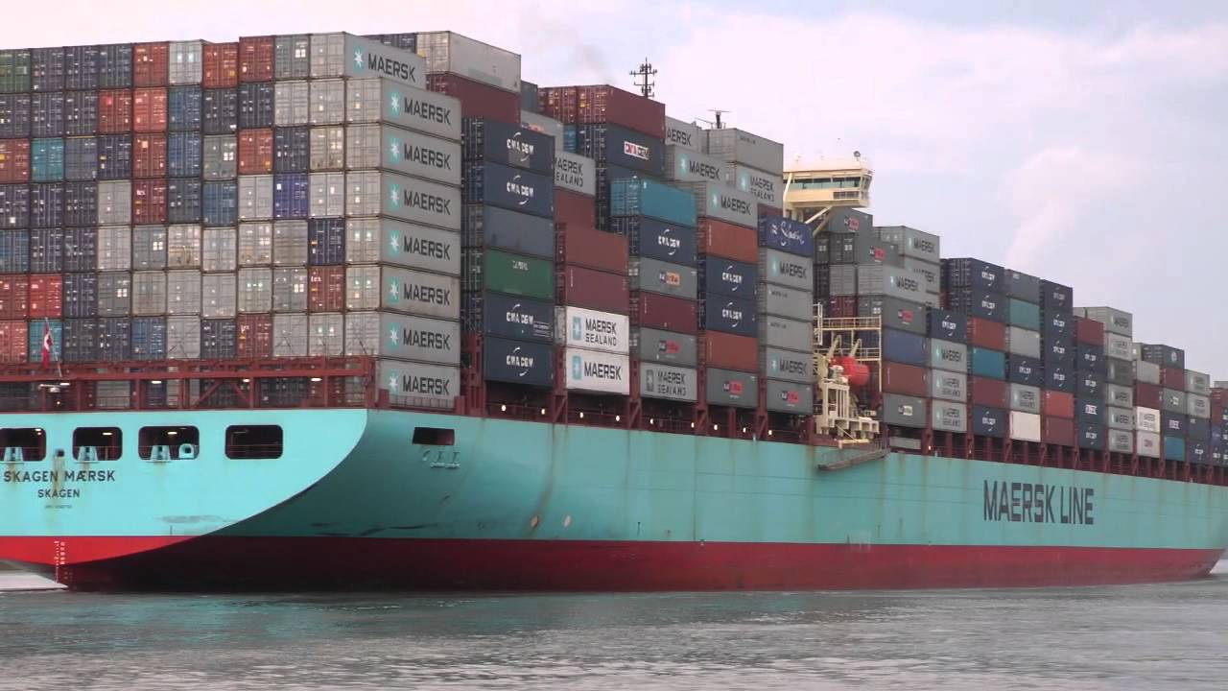
Source: Image

Explicit Details:

Implicit Details:

Inquiry Questions: How has this style of transportation revolutionized trade (and globalization?) (pg. 46 textbook)

My Response:

Communication & Media Technology as a Globalizing Force

Just as containers revolutionized the way goods are transported, so the computer and media technologies revolutionized the way information flows. (textbook pg. 47 - graphs). The development of computers took a huge leap during WWII, but the Internet wouldn't appear until the 1990s for everyday consumption. Since then, the explosion of information (and misinformation) has become a force to be reckoned with. Information spreads at such a rapid rate that we are unable to contain information or keep hold on facts.

Positives of Rapid Communication | Negatives of Rapid Communication

Media Concentration & Media convergence: Good or bad? (pg. 49)

PROs:

CONs:

RESPONSE:
Choose one of the quotes to respond to:

- Globalization Was created by the few for the many
- Globalization has enabled individuals, corporations and nation-states to influence actions and events around the world - faster, deeper and cheaper than ever before - and equally to derive benefits from them.
2. Identity and Economic Dimensions of Globalization (pg. 50)
Canadians eat about 3 billion bananas a year - about 100 bananas per person. After apples, bananas are the most popular fruit in Canada. Why do you think they are so popular?

Ecuador, bananas and the economics of Globalization
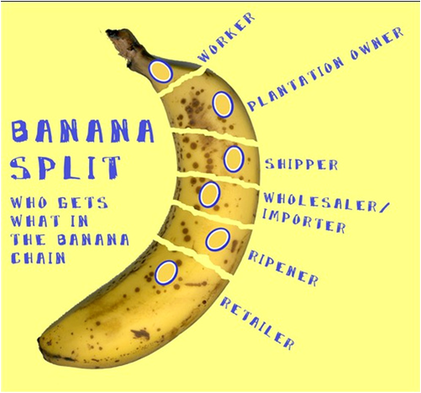
Pg. 51-55 - Read
Sam the Banana Man - https://en.wikipedia.org/wiki/Sam_Zemurray
Banana Wars: World Cafe Day
(need: open mind, discussion topics, table questions, placemat)
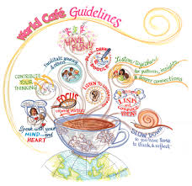 The banana wars

Biodiversity and Disease:
Cavendish species under threat - news article

Organic Bananas: Is this the answer?
Banana Boycott: Is this the answer?
Social impacts of the Banana production
- Health
- Education
- Lack of unions
- Displacement of indigenous peoples

3. How do Some forces of Globalization present challenges to identity?

Definitions -
- Homogenization:
- Acculturation:
- Accommodation:
- Assimilation:

Case Study: The Metis People
- Who are the Metis?
- How is this an example of globalization challenging/shaping identity?

POINTS of VIEW (pg. 59) and Detecting BIAS
- Read each point of view.
- Do you detect bias in the remarks of either speaker?
- Is bias always a negative thing?
- Describe what you think Barber means by “Theme-parking” of culture. Create a drawing or collage of ideas that represents how your own culture of community might look in the world he envisions.

Saving a Language - Local News Article
- Presenter: Vicky Whinniandie

Reflect and Respond Pg. 60 - Discuss, write, respond.

4. How do some forces of globalization provide opportunities to affirm and promote identity?

- www.native-languages.org : how is this an example of globalization PROMOTING identity?

What does it mean to AFFIRM something? (use it in a sentence)....

The double edged sword of globalization - Article and UN report 1999
Response/Thoughts:

Cultural Revitalization - Read pg. 61-63
Important Ideas:

Critical Challenge - GLOBISH (learn Alberta)
SUMMATIVE PROJECT

