Social Studies 9: Chapter 5 - Immigration Laws and Issues

Chapter Question: How well do Canada’s immigration laws and policies respond to immigration issues?
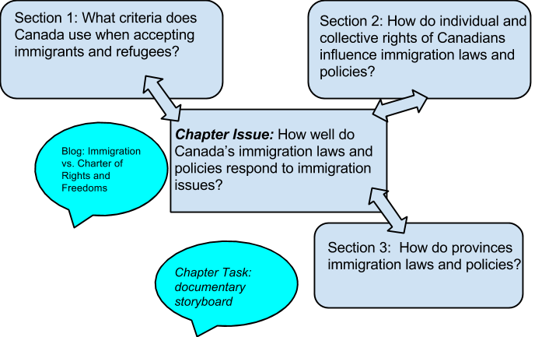

Vocabulary

immigration
demographic
Labour force growth
refugee
accord

Immigration and Refugee Protection Act
- Dates from .
- Most recent law dealing with immigration in Canada
- Establishes of who can come to Canada permanently from other .
- Also lays of the objectives of those categories.

(write in the different categories of immigrants and their corresponding %’s)
What are some of the objectives of the Immigration and Refugee Protection Act (2002)?
List them below:
-

-

-

-

-
-
Critical Thinking Pit-Stop: What are the underlying values reflected in the objectives of the act? What do they mean for citizenship and identity in Canada?

Source Analysis: pg. 168
What benefits of immigration does this source identify for Canada? (list two)

This source says......

1.

2.

LAW vs. POLICY
LAW =  POLICY = | Pictures/words to remember this.....

Adding up the points - cartoon (pg. 169)
1. How does the comic “Adding up the Points” demonstrate that economics is a factor that influences who Canada accepts as immigrants? Identify points in the story where this factor comes into play. What other factors - political factors, and health and security - can you identify in the comic?

TAKE the test yourself. Would you qualify? http://delivr.com/2zxse

The Points System:
- Dates from .
- Applies to immigrants. Refugees and immigrants do not have to qualify under the points system.
- If a person is NOT a refugee or family-class immigrant, they must apply under this system.

Health Factors for Immigrants:
- Potential immigrants must have proof they are in good health. People may be refused entry if:
- Their health could put the health of other at risk.
- They have a condition that could endanger public safety (ex. mental disorder)
- Their health could put and “ “ on Canada’s health services - for example .
* none of these apply to immigrant entering Canada as refugees or as family-class immigrants.

Immigration Laws: Past and Present
- No one is eliminated based on race or country of .
- In the past, Canada has favoured immigrants of ancestry and restricted immigration from countries, such as and .

Chinese Head-Tax: Find out more - http://delivr.com/2utm8

ADVANTAGES and DISADVANTAGES of points system:

Ads:

Dis:

Q #2: Working with a group of two or three, develop criteria for accepting new immigrants into the country. Think about what’s important - for example, what Canadians need, what is fair to applicants. share your criteria with the class (you have 10 minutes)

Refugees in Canada: Policy
Refugees is one of the categories of immigrants established under .
How policy on refugees evolved:
- Canada signed the U.N Convention relating to the Status of Refugees in .
- During the 1950s and 1960s, Canada offered to refugees in response to specific world crises.
- In , Canada made refugees one of its immigration categories. The change meant that canada accepted refugees steadily, instead of crisis by crisis.

Objectives of Immigration and Refugee Protection Act, 2002:

Read the Case Study on pg. 179: Answer the following question

Q: Why do you believe issues related to security affect immigration? Give a few reasons to support your opinion.

The Singh Decision

The Facts | The Results | Differing Opinions (pg. 182)
 |  | Which opinion do you agree with? Put a star beside the one you agree with most.

Challenges and Opportunities - Immigration and minority communities (FN and Franco-Albertan)

Section 3: How do provinces influence immigration laws and policies?

Using pg. 188 - 191, answer the Critical Challenge Pit-Stop questions below:

1. One objective of the immigration and Refugee Protection Act 2002 is to share the economic benefits of immigration across all regions of Canada. Based on the map and chart, how well has Canada achieved that goal?

2. Why might immigrants to Canada not choose to settle in Toronto, Montreal or Vancouver?

3. Why might they choose other cities in Canada? Why might they choose to settle in rural areas?

Provincial Nomination Program: (pg. 189)
- Under the Provincial Nomination program, can “nominate” a percentage of immigrants Canada selects each . The means, that Alberta can specify that it needs immigrants with particular .
- The program also allows some provinces to set up their own immigration offices in foreign .
- Governments in Canada can’t immigrants to settle in particular places or work in particular jobs. The Provincial Nomination Program increases the likelihood that immigrants will in the provinces whose labour needs match their skills.

Question:
1. What issues related to immigration might economic changes create?

Alberta Immigration Website short url: http://delivr.com/2sqaj
2. What type of workers is Alberta looking for/need? (use website and pg. 190)

3. What challenges face Alberta without enough immigrants? how can Aboriginal peoples be part of a solution to meet labour shortages? How do these questions connect to your quality of life as someone living in Alberta?

The Canada-Quebec Accord (pg. 191)
- The Canada-Quebec is a specific agreement with Quebec.
- Under the accord, can nominate the percentage of immigrants to Canada that corresponds to its population within Canada
- The accord also allows Quebec to immigrants who settle in Quebec to send their children to schools.
- Under the Canada-Quebec Accord, Quebec seeks whose first language is French. Every year, about of French-speaking immigrants to Canada settle in Quebec. Overall, more non-Francophone immigrants settle in Quebec that Francophone immigrants.

Critical Challenge Pit-Stop:
1. Based on this information, how does the Canada-Quebec Accord attempt to strengthen the French language in North America? Consider what you learned about the rights of official language groups under the Charter of Rights and Freedoms in Chapter 4. How does the accord reflect those rights?

