Chapter 3 Cloze Notes
The Origin and Growth of Liberalism
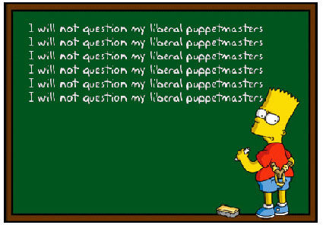
Unit Two
- Where do we come from?
- What are we?
- Where are we going?
To understand what liberalism is and how it affects us we must examine the development and ________________ of liberalism.
Uncovering 19th Century Liberalism
Chapter 3
- To what extent can classical liberalism impact a society?
____________ liberalism puts greater focus on _____________ freedom
Classical liberalism originated in __________ ____________.
Classical Liberalism
- Stresses the importance of human rationality
- Classical Liberalism is an ideology that embraces the principles of individualism.
  - ____________________________
  - ____________________________
  - ____________________________
  - ____________________________
  - ____________________________
  - ____________________________
  - Classical liberalism means the original ideals or liberalism
  - Liberty essentially means ‘freedom’, therefore liberalism is an ideology based on freedom
- Classical liberalism values political freedom and a free market economy that has limited government intervention within the economy.
- Modern liberalism is different because it advocates a greater role for the state in society.
- Therefore
liberalism
Proposes less government involvement with the economy

Liberalism:
Proposes government regulations with in the economy

Development of Classical Liberalism
- The following events help shape classical liberalism:
  - ___________________
  - ___________________/Age of Reason
    - Humanist
  - _______________ Reformation
  - _______________ Revolution
  - _______________ Revolution
  - _______________ Revolution

1400-1600 The Renaissance
  - Awareness of _______________ grew

1517- The Protestant Reformation
  - Growing _______________

1700’s- The Enlightenment/Age of Reason
  - ______________ values were strengthened

1750-1850- Industrial Revolution
  - Economic freedom grew along with individual values.

1776- American Revolution

1789- French Revolution

1900’s- Liberalism

Renaissance
- The Renaissance fostered the belief of _________________ in society
- The Reformation built on the ideas of the Renaissance by transforming the Christian faith through the importance of _______________.
- Ultimately both of these events fueled the Enlightenment or the Age of Reason, and as a result Classical Liberalism was born.
- Within the Enlightenment a group of Italian and French philosophers called _________________, emerged.
  - Humanist developed an interpretation of history, structure of society and life based on reason and _____________ opposed to __________________.
Protestant Reformation
- The Reformation dramatically altered the political, economic and social circumstance of Europe by opposing the ______________ Church.
  - It also challenged the ________________ concentration of religious power and any corruption of this power at this time.
  - Many high priests at the time asked peasant for donations in order to ensure their acceptance into heaven. Ex Notre Dame
Enlightenment
- The Enlightenment was a time period of great political and economic change which was proposed by thinkers and philosophers of the era.

REMEMBER:
- European society at the time was divided into 3 classes or ____________________
- At this time Kings ruled by _________ ____________and the economy was organized by the feudal system.
- With the ideas of the Enlightenment came the breakdown of the ____________ economic order, since people became more involved in oversea trade, urbanization grew and a wealthy middle class emerged. (industrial Revolution)
- At the same time there was political struggles for a less ___________________ rule which challenged the status quo.
- As a result Classical liberalism emerged which was a political and economic philosophy that encouraged:
    - The primacy of individual rights and freedoms
    - The belief that humans are _______________ and can make rational decisions that will benefit both themselves and society as a whole
    - Economic freedom, involving the ownership of private property and _______ ________________ (markets with limited government intervention)
    - The protection of ___________ _________________
    - ______________ _______________ on the government
Thinkers of the Time
- The following thinkers of the time contributed to the ideology of liberalism:
  - Thomas ___________
  - John _______________
  - Jean-Jacques ______________
  - Charles de Secondat, baron de _________________
  - Adam _____________
  - John Stuart ________________

Thomas Hobbes (1588-1679)
- English Philosopher
- He believed human nature is characterized by fear, violence, and dangerous self-interest (extreme individualism)
- He believed that if everyone is free, then everyone is in danger; that security is more important than freedom
- He did not think it was possible to have both security and freedom
- Individuals must give up their sovereignty in exchange for security.
- Review
John Locke (1632-1704)
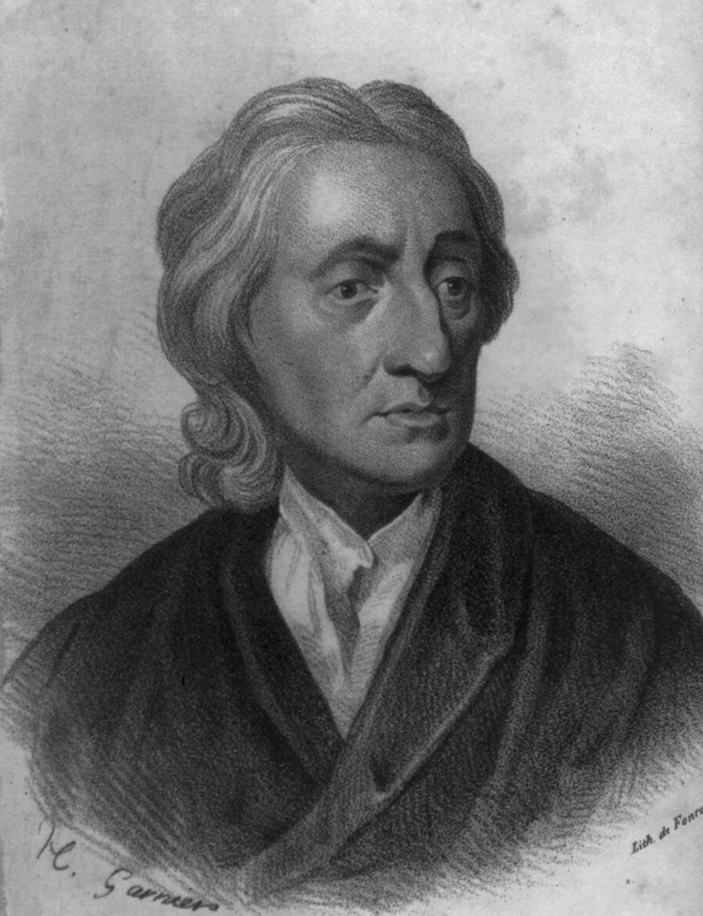
- Also an English philosopher
- Unlike Hobbes, Locke believed humans are
rational, intelligent, and reasonable.
- Locke opposed the authoritarianism of the Church and the state and believed that individuals had the right to use their reason and logic to make their own decisions.
- He also believed the source of power was the people themselves.
- He believed that any government action had to be justified by _____________ __________________ (democracy).
- However he believed in the ___________ _______________ where people must give up some of their rights to a government for social security.

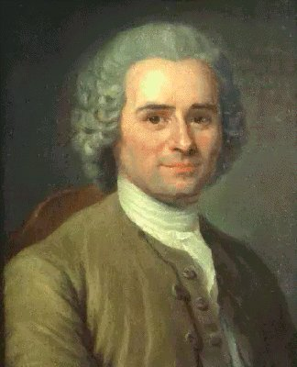
Jean-Jacques Rousseau
(1712-1778)
- Swiss Philosopher
- Believed people are inherently good but have been corrupted by society and civilization
- Believed men are naturally free and equal
- Wanted humans to go back to these natural, good characteristics
- He believed the will of the people was the absolute authority but, unlike Locke, did not believe in representative democracy, but in a direct democracy
- He believed citizens should make the laws directly
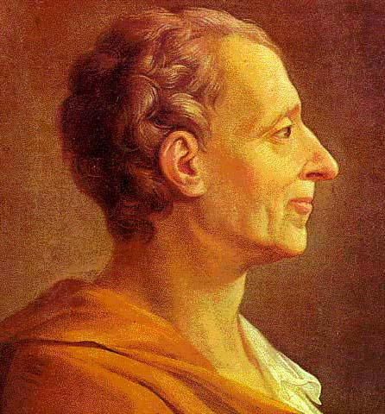
Charles de Secondat, baron
de Montesquieu
(1689-1755)
- French Enlightenment thinker whose
writings were banned by the Catholic church
- Montesquieu believed in the worth of the individual, the equality of individuals, and the accountability of the government.
- He also believed strongly in the ___________ ____ _______________ in government (______________, _______________, and _______________).
- Within this system of Checks and Balances each branch would be both separate from and dependent on one another so that no one branch became too powerful.
- However in order for this system to work people needed to be involved in government-a democracy.

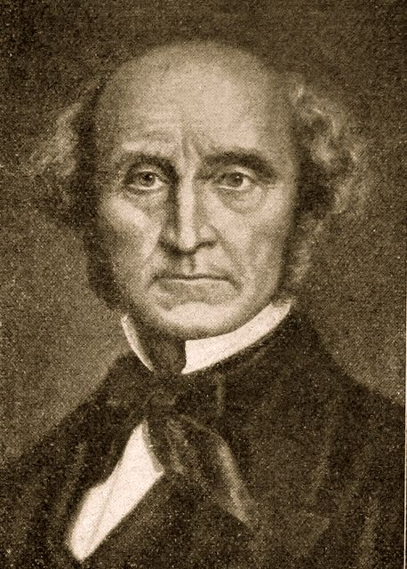
John Stuart Mill
(1806-1873)
- English philosopher
- He was interested in the protection of
individual freedom and the promotion of individual decision making as the core of societal institutions
- He believed that the only limitations that should be placed on the individual were those that would protect others (i.e. The only restrictions on people should be those that prevent harm to others)
- Mill also strongly advocated free speech
- Industrial Revolution: The Origins of Laissez-Faire Economics
- In approx 1750 the Industrial Revolution occurred in Great Britain.
- Britain’s economy was traditionally based on agriculture however during the Industrial Revolution this changed to a factory based system in urban centers.
Industrial Revolution in Great Britain
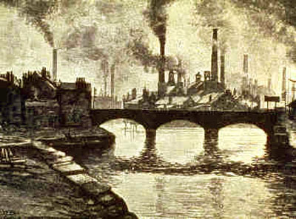
- The Industrial Revolution began in Great Britain for the following reasons:
  - Great Britain had a large naval and merchant fleets that could be used to trade with other areas of the world and gain resources of distance colonies.
  - Britain also had a large investment capital and cheap labour with many inventors causing new _______________.
  - Power was shared between the ______________ and the ________________. Parliament was made up of powerful land owners. This lead to the Enclosure Act which privatized farm land forcing thousands of small farmers to the cities looking for work.
  - Britain and the world were influenced by the Enlightenment thinkers which favoured __________________

Results of the Industrial Revolution
- Together these resulted in:
  - The development of the ______________ system
  - _________________ of labour
  - Mass production
  - Consumption of __________________ goods
  - Expansion of capitalism and free _____________________
  - A large _______ between the extremely rich and the extremely poor
  - _____________
  - Starvation
  - _____________ ____________ and worker abuse along with
  - The degradation of the ___________________
Laissez-Faire Economics
- French term- “leave (people) alone to do (as they wish)”
- It referred to a __________________ of _____________ ________________ in the economy
- It emerged from the theories of the _______________________.
  - a group of Enlightenment philosophers in France who critiqued the prevailing economics of _______________________.
  - Mercantilism is the idea that the primary goal of the economy is to strengthen the power and wealth of the state. In order to do so high government regulation is necessary.
- Laissez-faire reflects the following ideas:
  - Individuals need to be given freedom to make their own decisions. Therefore laissez-faire is ____________________ mercantilism.
  - Individuals’ selfishness and competitiveness will eventually _____________ their own society.
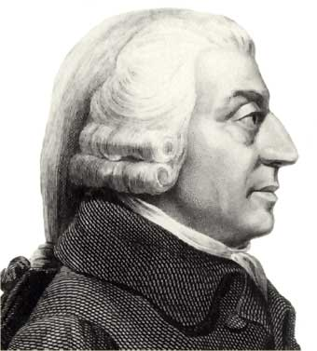
Adam Smith
(1723-1790)
- Scottish political economist
- He believed that if people worked first and foremost for themselves, everyone-including the state-would be better off.
- He published The __________ ___ ____________ (1776) in which he insisted individual self-interest in a free-market would strengthen the economy and benefit most people.
- He provided the foundation of much of the capitalist system
The Evolution of Classical Liberal Thought
- How did classical liberal thought evolve into the principles of liberalism?
- The American and French Revolutions in the late 1700s were attempts to implement the ideas of liberal thought.
The American Revolution
- Liberal thinkers inspired the American colonists to declare independence from the British crown and establish a republican form of government where governing authority was invested in the hands of its ________________ and not a ruling monarch.
The French Revolution
- Following the American Revolution, the French Revolution was an attempt to transform society using _____________ principles.
Recall reasons for the French Revolution...
  - Social: The class system of the 3 estates
  - Political: people had no say within the government and Estates General failed
  - Economic: unequal taxation, expensive wars, lavish spending of the king.
Compare liberalism to The Declaration of the Rights of Man and of the Citizen...
  - “men are born and remain free and equal in rights...”
  - “Rights are liberty, property, security and resistance to oppression..”
  - “Liberty consists of freedom to everything which does not injure anyone else..”
  - “Law is the expression of the general will..”
  - “Free communication of ideas and opinions is one of the most previous of the rights…”
Aboriginal Influence on Liberalism in North America
- The Great Law of _____________, or the ___________________ of the Haudenosaunee Confederacy, established equal participation of the people, including women, in the government. It also guaranteed certain rights and freedoms, including freedom of speech and the rights of individuals.
Homework
- Read Voices on p 116- 117.
  - Then complete the accompanying questions.
- Complete “Explore the Issue” on p 118
  - Do questions 1,2,3
Liberal Principles in Action
- The principles of classical liberalism had become widespread in Western societies by the 19th century.
- This was the culmination of the political, economic, and social dynamics of the previous centuries.
- It culminated in with industrialization and capitalism
- This eventually led to the evolution of classical liberalism into modern liberalism
The Industrial Revolution
circa 1750-1900
The Industrial Revolution was...“the most far-reaching, influential transformation of human culture since the advent of agriculture eight or ten thousand years ago. The consequences of this revolution would change irrevocably human labour, consumption, family structure, social structure, and even the very soul and thoughts of the individual.” -Richard Hooker
How are liberalism, capitalism, and industrialization linked?
- Enclosure movement was created because of new technologies such as the seed drill.
- This movement pushed many people to the cities because they were not needed any more.
- Deregulated mercantilist system caused a free-trade approach to the economy which provide more capitial for the Industrial Revolution to occur and spread.
- Let’s look at the connections...
- The Enclosure movement led to the industrial revolution...how?
- Liberalism essentially means ‘freedom.’ In what way did the Industrial Revolution allow people more freedom than agriculture or the feudal system?
For homework...
- Read the Voices section on page 123 and answer questions 1 & 2.

