Chapter 7: The People of the Sun
Aztecs aqueduct compulsory tribute
Name:

Worldview Inquiry: In what ways do a group’s collective beliefs and experiences contribute to shaping a unique identity?
Opening Chapter Story:
- Questions:
  - What effect do you think the experience of hardship and wandering might have had on the Aztec sense of identity?

  - Can you name another group of people who wandered through the desert before being led to a promised land?

For the Aztec people, a was more than a physical site. They saw the mountain as a sacred or holy site, one that, through its height, brought people physically closer to the . For the Aztecs, the world consisted of two landscapes – physical and - that were closely connected. The temples the Aztecs built to worship their gods were pyramids in the shape of .
MAP of Mexico – Sketch/Draw one below (using fig. 7-2).

The Aztecs believed that their god Huitzilopochtli had led them to the place where they lived. In many ways it was not an ideal location. (read page 153 to find out why and list below):
- 1.
- 2.
- 3.
The mountains that surrounded Tenochtitlan gave the Aztecs a sense of security. Like the walls of a fort, the mountains protected the city from attack by .
The mountains that protected the Aztec also caused problems for them. HOW??? List below:
- 1.
- 2.
Zoom In: The Floating Islands
- What is a chinampa?

- How were these built?

- Questions 1: (pg. 154)

- Questions 2: (pg. 154)

Mexico City is Sinking pg. 157
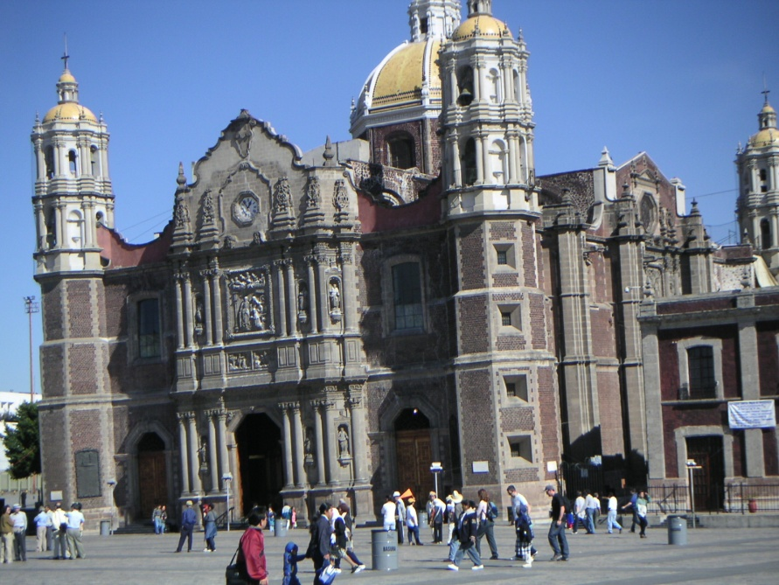
The capital of present-day Mexico, Mexico City is built on the ruins of Tenochtitlan. The Spanish destroyed the city after they conquered it in 1521. They built their city on top of the Aztec ruins in the lake bed. A century later….(keep reading)
Think it Through (for marks!)
- Today what two major factors are contributing to the sinking of Mexico City?

- Consulting with Aztec engineers may have helped avoid some of the problems the Spanish builders experienced in the first 100 years. In what other areas might Aztec knowledge have helped the Spanish?

Aztec Gods
Mini-Group Projects
Create a short presentation (based on research from text and internet sources) that teaches about one of the Aztec gods listed on page 159 in your textbook. You must ALSO put together a visual of how the god was respected/feared by the Aztecs. NOTE: this must be original and not from the internet (research can, but visual cannot be)

Measuring Time: Aztec Calendars
Questions: How does the calendar show both the Aztecs’ respect for and fear of the sacred world?

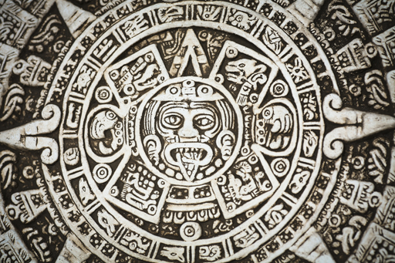http://www.learnalberta.ca/content/aeve/movieLauncher.html?movie=smil/aztec_empire.mov
My Answer:

Human Sacrifice
Of all aspects of the Aztec worldview, the practice of human sacrifice may be the hardest for us to understand.
READ the section of page 161 to answer the following question:
WHY did the Aztecs believe it was necessary to give the gods human blood?
My Answer: (point form or summary of section of page 161)

Tenochtitlan: The Center of the World
According to Aztec philosophers, the was a round, flat disc divided into sections. In the middle, where the sections met like the pieces of a pie, was Tenochtitlan, the capital city of the . The Aztecs firmly believed that the gods had assigned them a special place or location in the universe.
DESCRIBE how the city was organized (pg. 163)

Expanding the Empire
Summarize the following sections yourself, then from what you learn through the teacher presentation:
 | MY summary | Extras from presentation (Things I should know)
Expanding Through Trade
Expanding Through War

Exit Questions/Need to Know:
- Huitzilopochtli – who was this? Why are they important?
- Why were mountains important to the Aztec people?
- What is a chinampa?
- What belief led the Aztecs to decide to settle in Tenochtitlan?
- Today, what two major factors are contributing to the sinking of Mexico City?
- Name 2 Aztec gods and describe what purpose they served to the Aztec people.
- Describe how an Aztec calendar works.
- Why did the Aztecs use human sacrifice?
- Describe the physical organization of Tenochtitlan and why this was important to the Aztec people.
- Who was Diego Rivera?
- What were the two ways that Aztec people expanded their empire?
- Why did Aztec people need to trade?
- Why was military service compulsory for Aztecs?
- Describe the importance of war and military for the Aztec culture

