Classroom Expectations
For Students in Food Studies
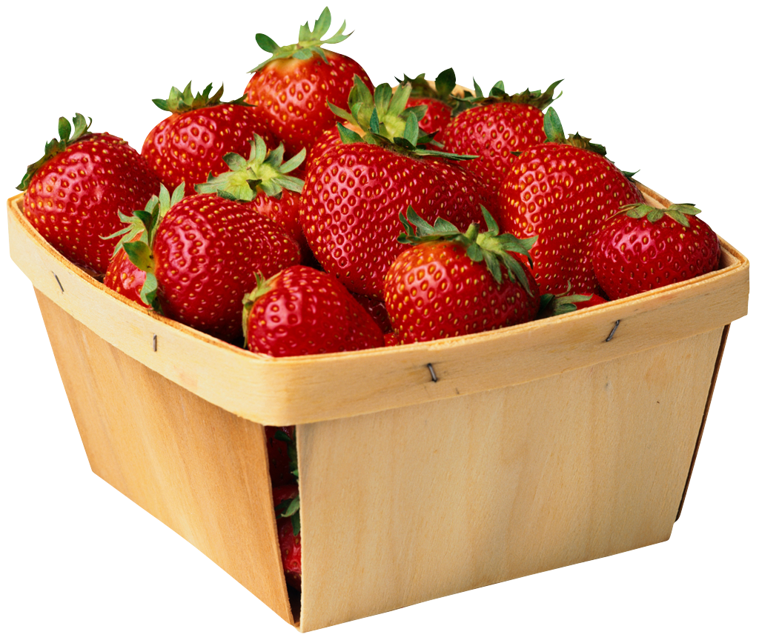

Practical:
Lab work should be carried out in an organized manner. All students must wear aprons, closed toe shoes, and long hair should be tied back. Good sanitary and safe practices must be adhered to at all times. Unwashed dishes, dirty counter tops, stoves, sinks, floors, untidy cupboards and careless breakage will result in a 0% for that lab. The instructor reserves the right to cancel labs if inappropriate work habits are evident. Missed labs may receive zero. Recipes and Evaluation sheets are required for all labs.

Theory:
All students will be expected to keep organized throughout the semester. Come to class prepared with all necessary materials (iPad, textbook, paper, pen, etc.)

Attendance:
School attendance policy will be in effect. The office should be notified if you are absent. You will be required to make up missed work. Be sitting and ready to start when the bell goes!

Daily Assignments:
These are to be handed in on time. Class time is given for completing assignments. If your written work is not done, you will not be cooking.

General:
Arrive on time to maximize your learning time.
Respect the rights and space of others
Shoes must be clean.
Cell phones must be out of sight and TURNED OFF.
Do not enter the supply room or open supply fridge unless instructed to do so by the teacher.
Cook and bake with integrity and pride.
Sharing with your teacher is encourages
Always leave your kitchen better than you found it!

