Foods 10/20/30
Course Outline – Mrs. Weber 2012-13

General Outcomes for Food Studies:

Students will develop an interest in the broad base of food and an awareness of the nutritional importance of foods. They will also develop basic knowledge, skills and attitudes through the preparation of a variety of foods in order to lead a richer and more fulfilled life or to enter the food service industry with increased confidence and success. Throughout the course, studetns will practice safe and sanitary food handling, foster an understanding and knowledge of the multicultural richness and varied cutsoms in the preparation and service of food.

Evaluation:  Lab work: 30%  Written assignments: 25%  Module project/testing: 20%  Management skills: 10%  Reflection/blog work: 20% | 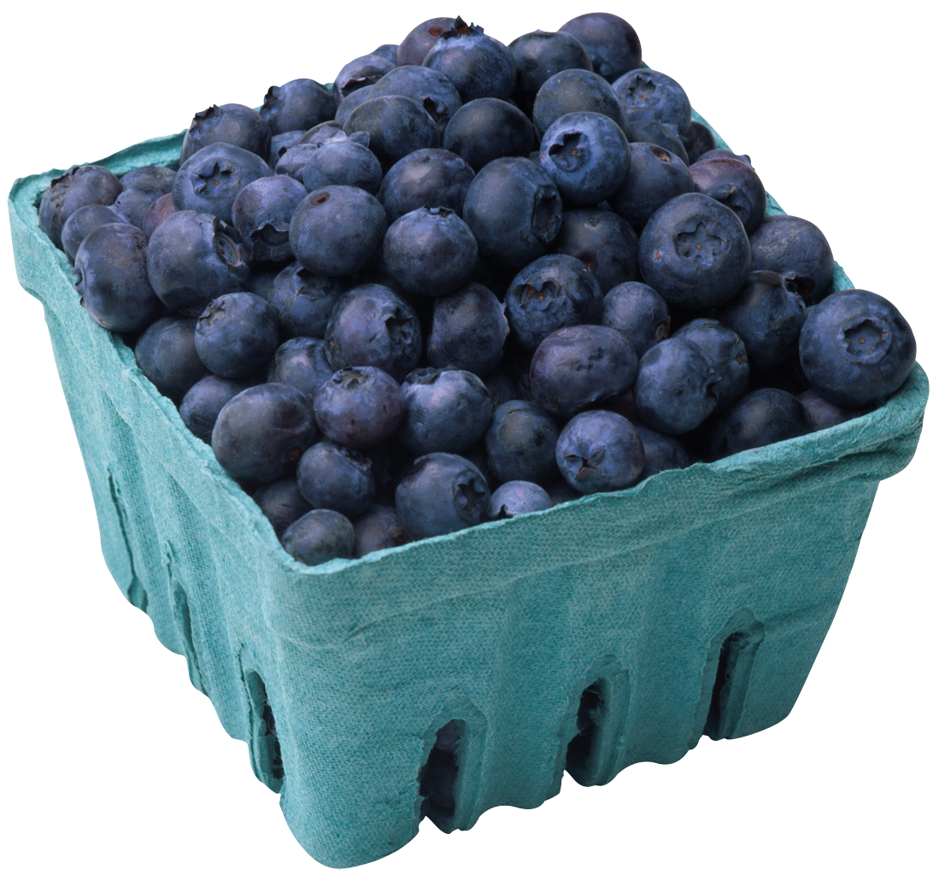 | Resources:  Text book –  Variety of Cookbooks, videos  iPads  Blogger  Various apps  Industry Partners  Online references

Foods 10: Expected to complete 6 modules. One credit per module.
Foods 20: Expected to complete 5 or more modules. One credit per module.
Foods 30: Expected to complete 5 or more modules. One credit per module.

