TITLE: PNF Stretching
(Proprioceptive neuromuscular facilitation)
Suggested Time: 1 class
Lesson Summary
Suggested Activities:
- Start lesson in classroom with PowerPoint on flexibility/stretching introduction
- Move to activity space for the following lesson:

Warm-Up:
- 10min-15 of cardio fitness of any kind
- Dynamic warm-up (shuffles, butt kicks, grapevine, high knees)
Stretching Routines:
Can be done together timed as a class in partners or as stations (see station cards- laminate for repeated use).
Teacher Notes:
PNF (proprioceptive neuromuscular facilitation) techniques involve a partner actively stretching the participant by some combination of altering contraction and relaxation of both agonist and antagonist muscles. Some of the different PNF techniques used include slow reversal hold, contract relax, and hold relax. PNF stretching usually involves a 10 second push phase followed by a 10 second relaxation phase, typically repeated a few times. PNF stretching is capable of producing greater improvement in flexibility compared to other techniques. Its disadvantage is that it typically requires a partner, although stretching with a partner may have some motivational advantage for some individuals.

PNF LYING GLUTE STRETCH

Instructions:
Preparation
Instruct participant to lie on floor or mat. Kneel beside participant. Bend participant's knee and hip and rotate leg cross wise. Position outside of participant's knee on nearest shoulder with participants lower leg extended under arm. Position near ankle on participant's opposite lower leg.
Execution
Extend or place hands on mat to each side of participant. Push participant's leg by leaning toward participant. Repeat with opposite leg.

Muscles
Target
- Gluteus Maximus
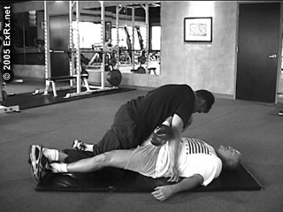

PNF SEATED GLUTE STRETCH

STRETCH

Instructions
Preparation
Instruct participant to sit on floor or mat, reclining back with support of both arms behind body, and feet on floor and knees bent. Have them cross their lower leg (just above ankle) over thigh of opposite leg. Position chest on participant's back and grasp participant's lower knee and upper ankle.
Execution
Push participant's torso toward legs. Hold stretch. Repeat with legs in opposite position

Muscles
Target
- Gluteus Maximus
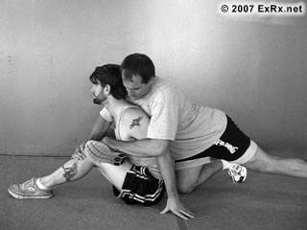

Instructions

PNF LYING PIRIFORMIS STRETCH

STRETCH
Preparation
Instruct participant to lie on floor or mat with legs bent. Stand near their feet facing them. Assist them crossing their thighs, placing outside of one knee close to top of their other knee. Bend over participant's hips, position their foot of closest bent leg on your chest or shoulder while grasping their lower leg, in addition to knee of opposite leg with other hand.
Execution
Push your bodyweight down on foot while pushing down on side of participant's knee. Hold stretch. Repeat with legs in opposite position.

Comments
Low back may be stretched if hips raise off of floor significantly. If spinal flexion is not desired, care should be given to keep back of hips on floor by monitoring hips position and pushing downward instead of toward participant's chest. See PNF stretch techniques. Also see Lying Piriformis Stretch for similar static stretch.

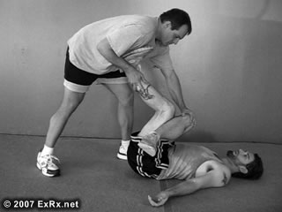
Muscles
Target
- Piriformis
- Quadratus Femoris

PNF SEATED PIRIFORMIS STRETCH

STRETCH

Instructions
Preparation
Instruct participant to sit on floor or mat, reclining back with support of both arms behind body, and feet on floor and knees bent. Have them cross their thighs by placing back of knee on thigh of other leg. Ask them position foot on floor closer to hip. Place your hands on back of participants shoulders or position your chest on participant's upper back and your hands under participant's lower thighs.
Execution
Push participant's torso toward legs. Hold stretch. Repeat with legs in opposite position

Comments
See PNF stretch techniques. A static Seated Piriformis Stretch can also be performed without assistance.

Muscles
Target
- Piriformis
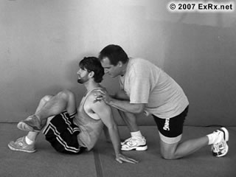
- Quadratus Femoris
Other (see comments)
- Erector Spinae

PNF LYING CROSSOVER STRETCH

STRETCH

Instructions
Preparation
Instruct participant to lie on floor or mat. Kneel beside participant. Bend participant's near knee and hip. Place hand on outside of participant's near knee and opposite hand on participant's shoulder.
Execution
Push participant's knee to opposite side while backing participant's shoulder down. Hold stretch. Repeat with opposite side.

Comments
Maintain 90° flexion in participant's hip while maintaining participant's shoulders flat on floor. See PNF stretch techniques. Also see Lying Crossover Stretch for similar static stretch.

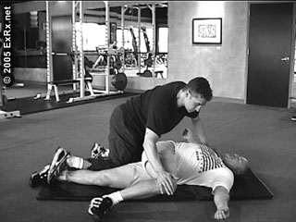
Muscles
Target
- Gluteus Medius
- Gluteus Minimus
Other
- Obliques
- Erector Spinae

PNF LYING HAMSTRING STRETCH

STRETCH

Instructions
Preparation
Instruct participant to lie on floor or mat. Kneel beside participant and extend participant's leg upward. Position back of participant's lower leg on nearest shoulder. Position near ankle on participant's opposite lower leg.
Execution
Push participant's leg close to participants chest. Place hands on floor with arms extended to control resistance. Repeat with opposite leg.

Comments
See PNF stretch techniques. Also see Lying Hamstring Stretch for similar static stretch.

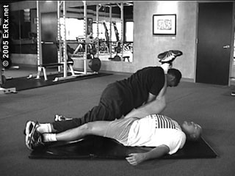
Muscles
Target
- Hamstrings

PNF SEATED HAMSTRING STRETCH

STRETCH

Instructions
Preparation
Instruct participant to sit with knees straight on floor or mat. Kneel behind participant and position chest on participant's back. Place hands just above knees from each side.
Execution
Push participant's torso toward legs with chest while holding down knees. Hold stretch.

Comments
See PNF stretch techniques. Also see Seated Hamstring Stretch for similar static stretch.

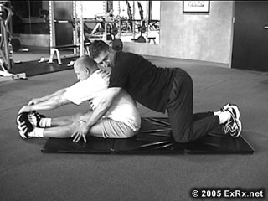
Muscles
Target
- Hamstrings
Other
- Erector Spinae

PNF LYING (PRONE) QUAD STRETCH

STRETCH

Instructions
Preparation
Instruct participant to lie prone on mat or floor. Straddle participant facing toward feet. Knee beside participant with leg extended over or just above participant's hips. Bend participant's near knee and place hand under participant's upper leg and opposite hand on ankle.
Execution
Lift knee and push ankle down toward hip. Hold stretch. Repeat with opposite side.

Comments
The opposite leg or thick towel can be placed under participant's near knee (and above participant's far knee) to further stretch Rectus Femoris. Tibialis Anterior can be stretched if ankle is completely plantar flexed.
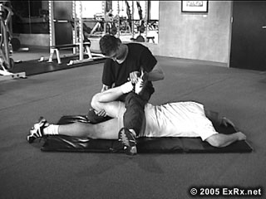
See PNF stretch techniques. Also see Prone Quadriceps Stretch for similar static stretch.

Muscles
Target
- Rectus Femoris
Other
- Quadriceps

PNF BENT LEG GROIN STRETCH

STRETCH

Instructions
Preparation
Instruct participant to lie on floor or mat. Ask them to place soles of feet together on floor close to body with knees apart. Kneel close to participant and place hands on insides of participant's knees.
Execution
Spread participant's legs down to sides and hold stretch.

Comments
See PNF stretch techniques. Also see Lying Wall Groin Stretch for similar static stretch.

Muscles
Target
- Adductors, Hip

PNF STRAIGHT LEG GROIN STRETCH

STRETCH

Instructions
Preparation
Instruct participant to lie on floor or mat with legs positioned straight up, slightly apart. Grasp participant's ankle from inside.
Execution
Spread legs down to sides and hold stretch.

Comments
Administrator may need to kneel down closer to partipants who are more flexible. See PNF stretch techniques. Also see Lying Wall Groin Stretch for similar static stretch.

Muscles
Target
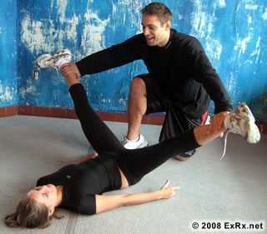
- Adductors, Hip

PNF BEHIND HEAD CHEST STRETCH

STRETCH

Instructions
Preparation
Instruct participant to sit on floor or bench and place hands behind head, facing forward. Stand behind participant and position leg behind their head. Place hands on participant's elbows.
Execution
Pull participant's elbows back. Hold stretch.

Comments
Participants hands can be clasped. See PNF stretch techniques. Also see Behind Head Chest Stretch for similar static stretch.

Muscles
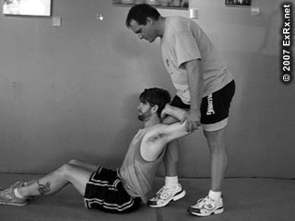
Target
- Pectoralis Major, Sternal
Other
- Pectoralis Minor

PNF OVERHEAD LAT STRETCH

STRETCH

Instructions
Preparation
Instruct participant to stand or sit on floor, chair, or bench and place arm overhead. Standing behind participant, grasp their wrist and position their forearm behind their head.
Execution
Pull participant's wrist toward back of shoulder. Lean torso to side, away from direction of arm behind head. Hold stretch. Repeat with opposite arm.

Comments
Participant can be asked to lean torso away from side with arm behind head. See PNF Overhead Triceps Stretch for similar exercise which can be performed with this stretch. Also see Overhead Lat Stretch for similar static stretch. Long head of triceps is only stretched if elbow nears complete flexion.

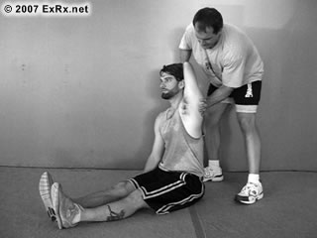
Muscles
Target
- Latissimus Dorsi
Other
- Teres Major
- Triceps, Long Head (see comments)

PNF OVERHEAD TRICEPS STRETCH

STRETCH

Instructions
Preparation
Instruct participant to stand or sit on floor, chair, or bench and place arm overhead. Standing behind participant, grasp their wrist and position their forearm against upper arm.
Execution
Pull participant's elbow behind their head while keeping forearm against upperarm. Hold stretch. Repeat with opposite arm.

Comments
See PNF Overhead Lat Stretch for similar exercise which can be performed with this stretch. Also see Overhead Triceps Stretch for similar static stretch.

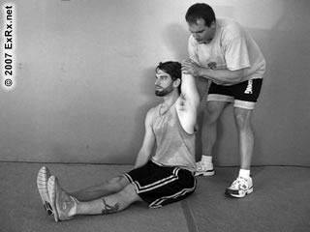
Muscles
Target
- Triceps, Long Head
Other
- Latissimus Dorsi
- Teres Major

PNF SEATED BICEPS STRETCH

STRETCH

Instructions
Preparation
Instruct participant to sit on floor or bench and place arms to behind hips. From behind, grasp participant's wrists, positioning them downward and close together.
Execution
Continue to raise participant's arms upward behind their body. Hold stretch.

Comments
Participant's wrists must continue to face downward. See PNF stretch techniques. Also see Seated Biceps Stretch for similar static stretch.

Muscles
Target
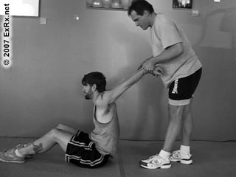
- Biceps Brachii
Other
- Deltoid, Anterior
- Pectoralis Major, Sternal
- Pectoralis Major, Clavicular

PNF SEATED FRONT DELTOID STRETCH

STRETCH

Instructions
Preparation
Instruct participant to sit on floor or bench and place arms to behind hips. From behind, grasp participant's wrists, positioning them wider than shoulder width.
Execution
Continue to raise participant's arms upward behind their body, out to sides. Hold stretch.

Comments
See PNF stretch techniques. Also see Seated Front Deltoid Stretch for similar static stretch.

Muscles
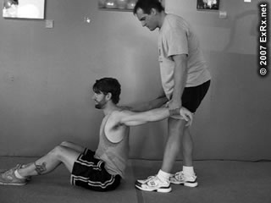
Target
- Deltoid, Anterior
Other
- Pectoralis Major, Sternal
- Pectoralis Major, Clavicular
- Biceps Brachii

