Political Cartoons – Evaluation and Creation
Weber Social Studies 9
Name:
Date:
Vocabulary: Please describe and define the following terms
Implicit Meaning
Explicit Meaning
- Political Cartoons – Worksheets and Review: For each cartoon, complete an evaluation sheet.
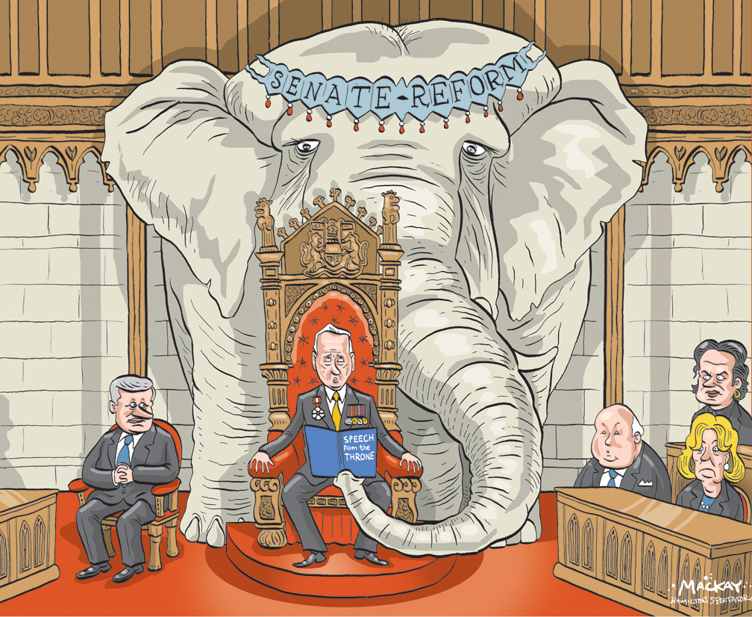
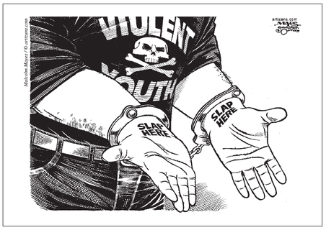
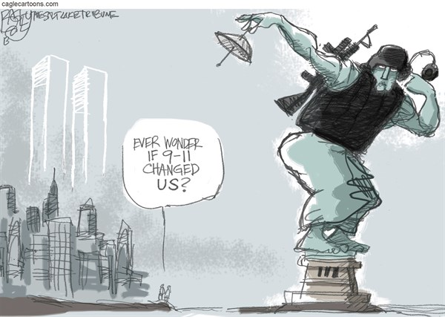

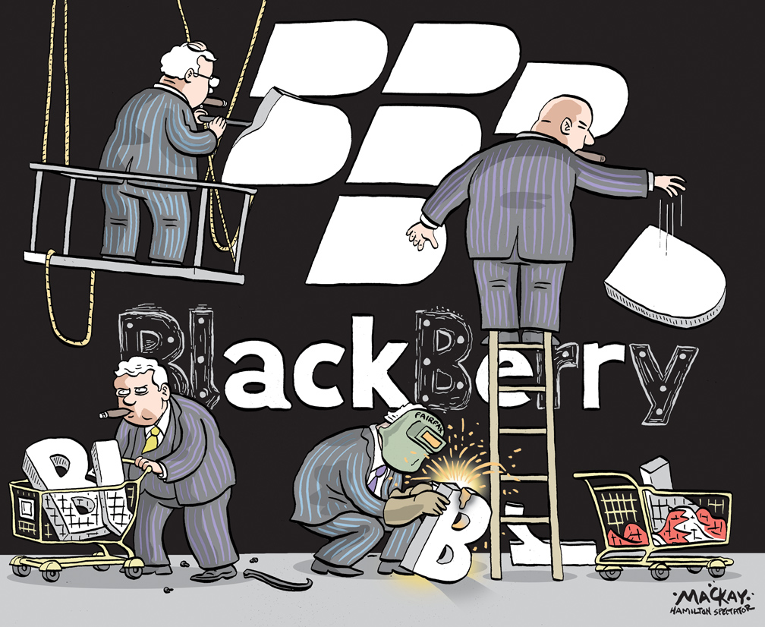
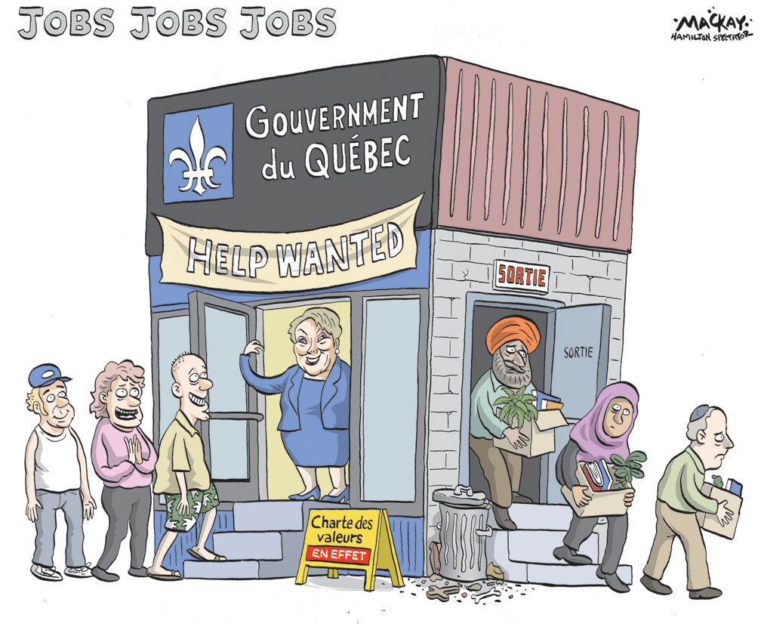

- Create your OWN political cartoon!
- Your cartoon will focus on an issue in Canada today (YCJA, Charter or Rights and Freedoms, Judicial System, Aboriginal Issues, etc.)
- It will likely be easiest to choose something in the news right now. Research a story from Canada, and then create a cartoon based off of it.
- You should include everything that is on your worksheet to evaluate the other 5 cartoons in this booklet.
- Create your cartoon below:

My Cartoon:

