**ESSENTIAL QUESTION #7: DIGITAL CITIZENSHIP**

**Adults believe that teens are extremely advanced in using modern technology but lack proper boundaries and wisdom when using cell phones, email, social networking sites and gaming devices. Why do you suppose people think twice before breaking the law in our society but do not feel guilty when breaking the law in the digital world?**

**Create** a **Public Service Announcement (PSA)** either as a **Podcast** or **Video** to demonstrate your answer to the question: **Why do you suppose people think twice before breaking the law in our society but do not feel guilty when breaking the law in the digital world?** Make sure that you are incorporating your background knowledge of digital citizenship.

**Key words:**

Digital Etiquette

Digital Access

Digital Law

Digital Health and Wellness

Digital Security

Digital Rights and Responsibilities

Digital Communication

Digital Commerce

Digital Literacy

**Planning:** Graphic organizers help you organize the information you are trying to convey (show) in your public service announcement. You must choose graphic organizer one **or** two **and** planning diagramone **or** two.

**Graphic Organizer**: **/4 marks**

**PSA Deconstruction: /2 marks** Whatis the message of the PSA and how is it effectively communicated in the video or podcast.

**PRESENTATION:**  **/5 marks**

* Students must create a Podcast or Video

**Resources:**

* <https://sites.google.com/site/teacherquality/psa> - (How to guide)
* <http://oiep.cofc.edu/pv_obj_cache/pv_obj_id_9D38D9C116741D6204D4D520BB145190E0770000/filename/marshall-psa.pdf> -(Rubric)
* <http://saloproductions.com/public-service-announcements/psa-samples.php> -(Examples)

Present the information in your portfolio. You will also be asked to present this information on a Wiki. Determine what you are willing to share with your peers and other people online.

**CURRICULAR LINKS:**

* E-Learning: Outcome 5 (digital citizenship)

**Choose one:**

**Graphic Organizer** #1

**STORY TABLE**

|  |  |
| --- | --- |
| **Narrative (Voice)** | **Images, Media** |
|  |  |
|  |  |

**EXAMPLE**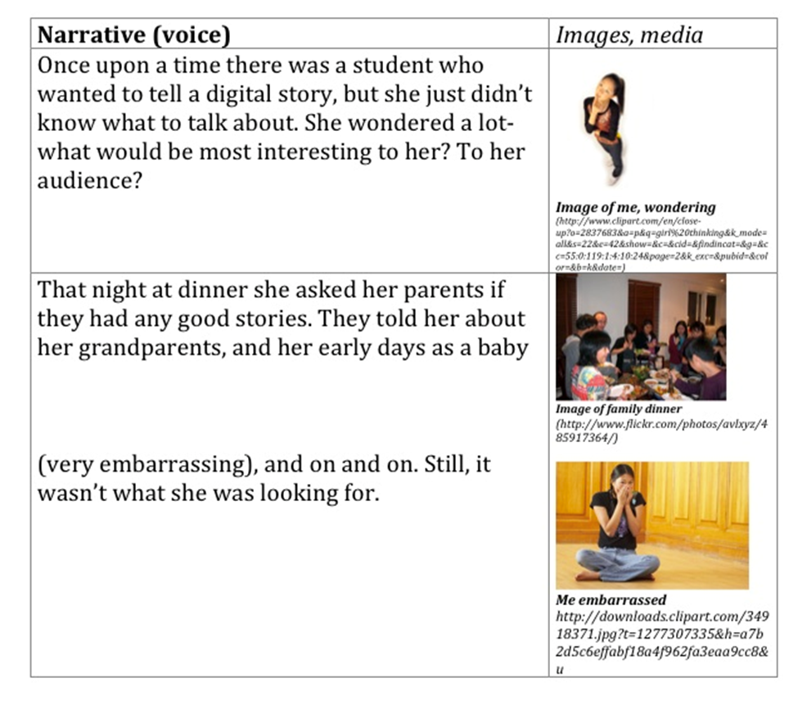

**Graphic Organizer #2**

|  |  |  |  |
| --- | --- | --- | --- |
| **Page:** | **Date:** | **Project name:** | **Author:** |
|  | | **Frame description** | |
|  | |
| **narration:** | | | |
| **media list:** | | | |

**Choose one:**

**Planning Diagram** #1



**Planning Diagram #**2

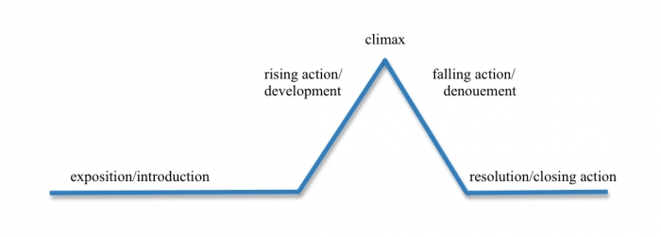

**RUBRIC:**

|  |  |  |  |  |
| --- | --- | --- | --- | --- |
| CATEGORY | 4 | 3 | 2 | 1 |
| Content | Students create an original, accurate and interesting PSA that adequately addresses the issue. | Students create an accurate PSA that adequately addresses the issue. | Students create an accurate PSA but it does not adequately address the issue. | The PSA is not accurate. |
| Fair Use | The PSA follows fair use for all music and sound effects that are included. All text is the original work of the group members or is used with permission. | The PSA follows fair use for most music and sound effects that are included. All text is the original work or is used with permission. There are some minor issues with copyright and fair use. | Most PSA is the original work of the group members, but some material is used without permission or in violation of copyright. | The PSA does not follow fair use practices. Text, sound effects and/or music is used without permission and/or in violation of copyright. |
| Collaboration with Peers | Almost always listens to, shares with, and supports the efforts of others in the group. Tries to keep people working well together. | Usually listens to, shares with, and supports the efforts of others in the group. Does not cause problems in the group. | Often listens to, shares with, and supports the efforts of others in the group but sometimes is not a good team member. | Rarely listens to, shares with, and supports the efforts of others in the group. Often is not a good team member. |
| Technical Production | Tone and voice convey emotions and enthusiasm. The recording is clear and loud enough to be heard. Background sounds and effects blend with the PSA’s message. | Tone and voice frequently convey emotions and enthusiasm. The recording is clear and loud enough to be heard. Background sounds and effects usually blend with the PSA’s message. | Tone and voice frequently convey emotions or enthusiasm. Most of the recording is clear and loud enough to be heard. Background sounds and effects sometimes distract from thee PSA’s message. | Tone and voice rarely convey emotions or enthusiasm. Recording is unclear and/or not loud enough to be heard. Background sounds and effects absent or distract from the PSA’s message. |