Social Studies 8
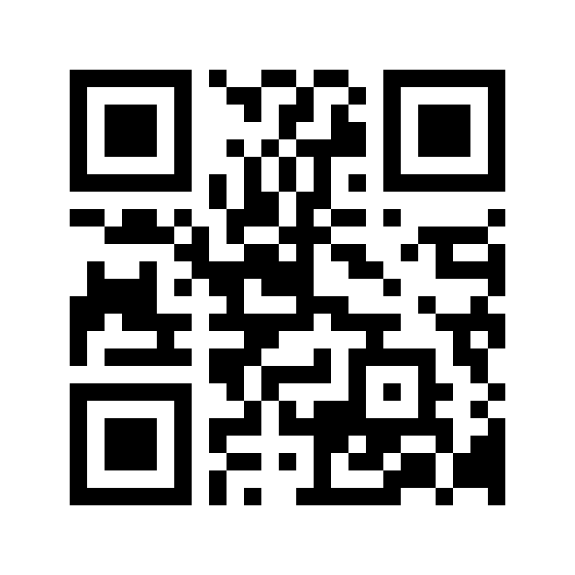
Mrs. Weber
2014 - 2015

There are three main units we will be covering this year:

1) Japan: From Isolation to Adaptation
2) Renaissance Europe: Origins of a Western Worldview
3) Worldviews in Conflict: The Spanish and the Aztecs

Each unit will contain quizzes, assignments, a unit final and/or project.

Current Events
On the last school day of each month, students will be required to find a current event (newspaper, online, etc.) and detail it in a short assignment. In total, there will need to be 10 current events. There will be a detailed handout of the process.

Daily Assignments........................................20%
Major Assignments......................................30%
Quizzes.............................................................10%
Final Projects/Unit Finals........................20%
Current Events..............................................10%
Final exam.....................................................10%

Resources:
Worldviews: Contact and Change - Textbook

Late Assignment Policy
An assignment may be docked up to 5% each day it is late up to a maximum of 50%. If there are circumstances that prevent completion of an assignment/project, please meet with me to discuss this AHEAD of time.

Rewrite Policy
If a student received lower than 50% on a quiz or unit final, they may re-write the quiz at a later date. This needs to be arranged by the STUDENT. If the student fails to arrange a re-write, they will not be given another opportunity to do so.

General Information
- It is the expectation of the student to keep a tidy and organized binder throughout the school year. It is also expected that assignments and projects are to be completed on time. Students are responsible for class work and/or assignments missed in the event the student is away from school.
- Expectations:
  - Arrive on time with ALL REQUIRED MATERIALS.
  - Be prepared to work, listen and participate.
  - Hand in all assignments/projects on time with your name and date on it.
  - Only quality work will be accepted. Anything deemed to be of low quality will be handed back without a mark.
  - Respect must be regarded at ALL times.
- Materials and Supplies Required:
  - 3 ring binder, loose leaf/scribbler, dividers.
  - Pencils, pens, pencil crayons, ruler, etc.
  - Issues for Canadians Textbook
  - Agenda (of your choice)
Flipped Classroom and Project-Based Learning
- This year, we will flip some of our lessons and students will be able to listen to class lectures on-line (houseofweber.weebly.com). It is the students’ responsibility to listen to the podcast to ensure they are prepared for the classroom portion the following day. Listening to the lectures is homework for the students. They can access the lecture on a smartphone, computer, iPod, iPad, etc. More information will come to the students about this process.
- PBL: learning through projects. We will be trying out PBL this year too!
I hope that you will have a very successful, productive and enjoyable year. Please feel free to ask for clarification on any class work or assignments that you are experiencing difficulty with. I am looking forward to working with you!

Mrs. Weber

