The Story of Canadian Aboriginal Spirituality
Key Terms: assimilate, elders, indigenous, shaman
* All google doc links, video links and other urls are available on the website.
Thinks I KNOW about Aboriginal spirituality | Things I WANT to know about Aboriginal spirituality | Things I have LEARNED about Aboriginal spirituality (end of unit)
1.  2.  3.  4.  5. | 1.  2.  3.  4.  5. | 1.  2.  3.  4.  5.

Read the prayer by Chief Yellow Lark on page 66.
Ideas:
Prayer reveals a great deal about the spirituality of Aboriginal peoples in Canada. The words of his prayer are very powerful expressions of his relationship with the Great Spirit and reveal a spirituality that is closely connected with tradition.

- Answer the following questions after reading through the prayer silently to yourself:
1. What requests is Chief Yellow Lark making to the Great Spirit?

2. What do the words o this prayer tell you about Chief Yellow Lark’s relationship with the Great Spirit?

3. Why do you think wisdom is so important to Chief Yellow Lark?

4. What role does nature have in the prayer? What does that tell you about Aboriginal spirituality?

Reflections on Aboriginal Art
Ideas:
Aboriginal paintings are often symbolic expressions of a spiritual integrations with nature and the creator.

Angel of the North (pg. 66)
- View painting
- Comments on style:

Woodland style of art
- Expresses Aboriginal spirituality (symbols, stories, beliefs and traditional wisdom)

Respond to the following question:
1. What does this painting tell you about the spirituality of the artisit?

Chapter Performance Task:
- Choose ONE of the following tasks to complete by the end of the unit (you will have time to work on this, but need to collect relevant information as we progress through the
1. Select one environmental issue and prepare a multimedia presentation explaining its impact on the lives of Aboriginal people in Canada
2. Gather information to create a children’s guide to an Aboriginal group or nation’s spirituality (way of life)

Guest Speaker - Omarla Cooke
Topic: Aboriginal People in Canada Today and the History of Aboriginal Spirituality
My Notes:

Read Aboriginal Peoples in Canada Today (pg. 68-69) and note the three main groups:
1. Inuit
2. Metis
3. First Nations

Create a Graph:
Research the following:
- Census information on the population of Canada =

- Using the information in your textbook and from the census, create a bar graph comparing Canada’s overall population with the number of Aboriginal peoples in Canada. Then, calculate the percentage of Canadians who are Inuit, Metis and First Nations.
- Homework Task: search for the Aboriginal community geographically closest to you, as well as any organizations, groups, or businesses associated with it. You will be sharing this information at the beginning of next class.

Jigsaw Activity: Scarboro Missions magazine
http://tinyurl.com/d74ldvm

In SMALL assigned groups, read your assigned section of the article and summarize it as a group. Each group will identify the elements of Aboriginal worldview presented in the article.
In HOME groups, create a graphic organizer that summarizes the key features of aboriginal spirituality presented in the article. (use the below organizer)

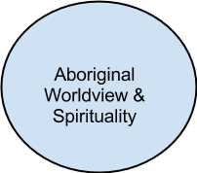

Read pg. 73
Q: What might the impact of each of the events had on Aboriginal peoples in Canada?

Define the word “assimilate” below:

Read the words of Black Elk on pg. 73 and respond in a journal style to the following question (email/hand in)

Q: “What do you think Black Elk meant by ‘square boxes’?”

Read pg. 74-75
- Reflect on the events of both European contact and recent history and select FIVE events that you think have been most challenging for Aboriginal peoples. For each event, you should express your reaction to it in a journal entry. Remember, consider these events from more than one perspective.
- Journal entries can be in the form of flowing text, or a combination of images and text, or a series of cartoons with balloon comments.
- You will be handing these in.
- You will also be doing a self-assessment on this journal.

Making Decisions through Consensus
Skill Focus: pg. 77
Photo of the first legislative assembly of Nunavut (pg. 76)
Principles of making decisions through consensus (pg. 77): Know these well
In your small groups, you are to discuss the following until you have reached consensus amongst your group.
1. In Canada, have we made progress in being tolerant and respectful towards all religions?
2. Do you think progress has been made in recognizing what other cultures have to contribute to Canadian society?

** Assessment: Group-Work Self Assessment

Rituals
Ideas:
As Christians, most of us have, at one time or another, experienced a sense of wonder and awe before the beauty of nature - the serenity of a quiet winter morning, the beauty of a fiery sunset, the power of a thunderstorm. Many believe that this is seeing God in all of creation.

- Psalm 104
http://tinyurl.com/bp3vk9c

- Catholic Hymn
http://tinyurl.com/bss2m9b

Read pages 81-85, summarize the information about rituals of Aboriginal spiritual traditions in a graphic organizer of your choice (t-chart, word web, concept map)
Your graphic organizer should include:
- name of the ritual
- the meaning and purpose of the ritual
- the sacred articles used in the article
- the manner in which the ritual involves a connection with the phyiscal environment
- the manner in which the ritual expresses the belief that all life is interconnected

(insert organizer here or create on a separate paper and attach to these notes)

Vision Quest: Storyboard Project
Read about life-cycle rituals (pg. 81-83), create a storyboard of a young person’s vision quest (see Make it Your Own pg. 81)
- Create a storyboard for a fictitious vision quest
- Rubric available

Government Ban on Potlatch
Read pg. 85 about the government ban on giveaways and potlatch ceremonies.

Do the Think About It question below:

- Consider the government ban on Aboriginal spiritual ceremonies. From your own perspective now, why did this happen? would it ever be reasonable for a government to ban a spiritual practice?
* small group discussion. T-P-S

Central Beliefs and Morality

Mother Earth Water Walk: http://tinyurl.com/blushx4. Read this article and discuss this news story.

Read about the Aboriginal concept of the spirit, the Great Spirit, and the Trickster. Summarize in the mid map below:

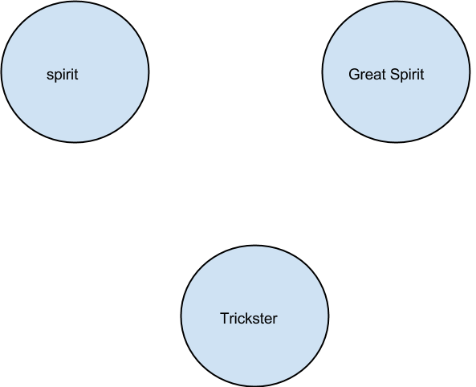

God the Holy Spirit (Christian/Catholic) | Similarities (if any) | The Creator

Q: Do you think it is possible for Aboriginal Catholics to honour the old ways of their ancestors and still be true to the Catholic faith?

Think:

Pair - Share:

IDEA: Is there room for both the peace pipe and the rosary? Read here to find out: http://tinyurl.com/cmfrma3

The Golden Rule:
- video: http://tinyurl.com/d3kkuk5
Why would all religions have the same moral principle?

The Shaman - Journal Reflection
- Read pg. 88.
- Compare the role of a shaman and a priest in a journal-style response below:

The Medicine Wheel: pg. 88-89
Point form notes below :

Ideas:
The Medicine wheel is a very important symbol. Since Aboriginal peoples do not have sacred writings, they work with symbols. Within the medicine wheel lie all the traditional stories and sacred teachings that shape the lives of Aboriginal people. When elders teach children about their relationship with the Great Spirit, how to pray, how to live moral lives, and how to solve conflict, they use the teachings of the medicine wheel, just as Catholics use the teachings of the Bible. Through the teachings of the medicine wheel, Aboriginal peoples pass on their spirituality and their way of life. For this reason we approach the medicine wheel as we approach our own sacred texts - with respect.

Reflect on the three core ethical teaching that guide Aboriginal moral life in light of their own moral principles.
- pg. 89
- Use ONE of the following statements to start your journal entry:
  - When you think about how you interact with other people in what way does your behaviour serve as an appropirate moral model for others?
  - When you think about your responsibility as a member of the school community, in what way are you a good member?
  - When it comes to showing respect for creation, the areas in which I ned the most work are...

CHAPTER PERFORMANCE TASK WORK BREAK - 4-5 class periods
- Choose one of the provided projects to complete.

Family Life
Prayer: A Prayer of Thanksgiving (read)
Ideas:
Colonization and modernity have had a significant impact on the lives of Aboriginal people. Our ever-growing dependence on technology has changed the way we live and communicate with each other.
Read pg. 90-92 - Aboriginal Family Life

Journal Question:
- Explain how you would feel if one of your favorite family traditions was taken away from them. Use examples in your journal for clarification.

The Eighth Fire Prophecy
Read pg. 92 - Seven Fires
Ideas:
Aboriginal peoples have been given the prophecy of an Eighth Fire. The prophecy suggests that if enough people - of all colors and faiths - turn from materialism and choose a path of respect, wisdom and spirituality, environmental and social catastrophe can be avoided and an era of spiritual illumination will unfold.

Think-Pair-Share
- How can we bring the world of technology and the world of spirituality together to form a more environmentally conscious country?
- How can the people of Canada develop a way of life that respects all living things?
- What would such a nation look like? What would be its guiding principles?

Dialogue
Chief Dan George - I am a Native of North America (google doc link)

Questions:
1. How does Chief Dan George see his “white brothers”?

2. What fear does he have for his people?

3. What does he see as the solution for hte troubles and strife of both Aboriginal peoples and non-Aboriginal people?

4. What would a relationship based on these principles look like in Canada today?

Compare and Contrast: Poetry - “Missionary” & “The Renaissance” (pg. 95-96)
Questions:
1. How does Father Rene Fumoleau approach dialogue with the people of his Dene community?

2. What imperative does Arthur Solomon say is driving the rebirth of Aboriginal ways of life?

3. Are both views optimistic and open to dialogue with the Church? Explain.

Blessed Kateri Tekakwitha - Timeline/Biography project
- In small groups, research and create a small biography and timeline of the Blessed Kateri Tekakwitha’s life. Each student in the group must make their own copy, but all must work together on gathering information.

Create a Symbol or Logo - Project
- Create a logo or symbol to express the mission of the Church to Aboriginal peopels in Canada as it is understood by the Church today:
- Rediscovering, Recognizing, and Celebrating the Spiritual Heritage of Canada’s Aboriginal Peoples - http://tinyurl.com/cnfd2nn
- Discuss the following Questions:
  - What does the letter reveal about the relationship between the Church and Aboriginal people in Canada?
  - What has the Church learned from its past relationships with the Aboriginal people about the nature of its mission?
  - How would you describe the Church’s mission to Aboriginal peoples in Canada today?
- Rubric - discuss criteria
- In groups, discuss and come to a consensus about how this mission migh be represented in a symbol or logo. The group will create a symbol/logo and will write an explanation together. The symbols will be on display for class.

