The Story of Hinduism
Key Words:
ahimsa  ascetic  atman  avatar  Bhagavad Gita  Brahman  caste  deities  Ramayana  samsara  Sanskrit  Vedas | dharma  guru  karma  mandir  mantra  maya  moksha  murti  puja  untouchables  Upanishads  yoga

Ideas:
When Hindus greet each other they commonly speak the words “Namaste” (nah-mah-STAY) while placing their hands together, fingers pointing upwards, and bowing respectfully to each other.
Namaste is more than a simple hello. When one Hindu greets another with this simple word, it expresses a whole attitude towards the other. It is a symbol of oneness with all things - one of the principle concepts of Hinduism. Namaste means “I bow with respect to you.”

USE THIS CHART AT THE END OF EACH LESSON
- To note any differences and/or similarities between Hindus and Catholics:
Distinct Beliefs, Precepts, and Practices of Hinduism | Similar Beliefs, Precepts and Practices: Hinduism and Catholicism | Distinct Beliefs, Precepts and Practices of Catholicism

Powerpoint - Namaste!
Discussion Questions:
- What can we learn about the belief of Hinduism from their greeting?

- What words or gestures do you use to show respect when you greet someone?

- Do Catholics have a special greeting that reflects similar beliefs of some central belief of their faith?

Ideas:
Namaste affirms the notion of the divine (God) living within all of us and confirms the dignity of all persons. This is a belief held by both Catholic and Hindus. As you learn more about Hinduism, you will see ways in which Catholics are dramatically different in their beliefs and ways in which they are similar. These differences and similarities are part of the beauty of human diversity and are a good starting point for the dialogue between Hindus and Catholics.

DRAW a symbol/image that represents the MEANING of Namaste:

Card Game: Vocabulary
- Create a card game and play it in small groups to become familiar with the vocabulary required in this Chapter.
- You will be evaluated using “Game Rating Scale” based on the game you create in your small group.

Harsha’s Personal Recollection: Read and Discuss
1. How has living in Canada affected how Harsha understands what it means to be Hindu?

2. How might living in a country that is primarily Hindu change the way you see your faith?

Chapter Performance Task - Choose ONE below:

1. Board Game:
- Students will create a board game based on a question-and-answer (Q & A) format to test their knowledge of Hinduism and to demonstrate critical-thinking skills (summarizing, organizing, categorizing) and communication skills (writing for instruction).
- Task Handout and Rubric
OR
2. Research Essay
- Students will research and write a brief essay on one of the following topics:
- The Caste System
- A Hindu Deity
- Hindu Beliefs
- Pilgrimages to the Ganges
- or a topic of your own choice (as approved by instructor)
- You will need to do an annotated bibliography and RATE this list of websites according to given criteria
- Task Handout and Rubric
** You will get approximately 2-3 classes to work on this project IN CLASS over the next week. It will be due at the end of the Unit.
Contemporary Music and Religion:
- Identify 2 contemporary artists who speak about YOUR faith tradition

- MC Yogi (Hinduism)

Hinduism in Canada: pg. 230

The Population of Hindus in Canada =
The Population of Hindus in the World =
COMPLETE “Canadian Hinduism Demographics” Handout (bar graph, mapping, and examination of a local community)

Research and Report: Web-Research
- Students will research the contributions of Canadian Hindus have made to Canadian society
- Choose one of the following to complete:
- Identify one Canadian Hindu who has contribute to Canadian society. Create a mini-biography of the events in his or her life that led to the contribution and descritpion of how that contribution of how that contribution has benefited Canadian soicety. The biography can be in the form of expository text or a biography web.
OR
- Research six Canadian Hindus who have contributed to Canadian society. Note their contributions and the positive effects they have had on Canadian society. Information can be presented in the form of a chart, concept map, or other graphic organizer of your choice.
** Assessment: Graphic Organizer Rubric (handout)

Ideas: (reference - World Map pg. 230)
The origins of Hinduism began in India and what is now Pakistan. The Indus River today is almost completely within the boundaries of Pakistan. Under British colonial rule (1600-1947 - see British East India Company), India encompassed both present-day India and Pakistan. Independence in 1947 was accompanied by great unrest and movement of populations. Muslims moved in great numbers to what became Pakistan, and many Hindus moved to India. Many Hindus migrated to Sri Lanka, Bangladesh, Burma (Myanmar), Malaysia, Indonesia, Nepal, Tanzania, Uganda, Fiji, Mauritius, Trinidad and Canada.

Illustrated Mind-Map
- Create an illustrated (pictures) mind-map to summarize the History of Hinduism (two links of houseofweber.weebly.com, as well as in your Student Book pg. 232)

Optional Enrichment: DI project (EXTRA MARKS if you want!)
~ Create a timeline on a major event in India's history:
~ First Indian War of Independence (1857-1858)
~ The Indian National Congress (1885)
~ Alexander the Great invaded parts of India (326 BCE)
~ The Salt March and the Rise of Gandhi (1930)

Rituals
Video: Puja - Expressions of Hindu Devotion (29 minutes) --> houseofweber.weebly.com
Discussion:
- How does engaging all of our senses make worship a more meaningful experience?

- What is the significance and purpose of the images of the deities used during puja?

- How is the practice of puja in mandir different and/or similar to a puja at home?

- Recall your own experiences of worship either at home or in a church. How are your senses engaged during this worship? How is this worship similar or different from Catholic worship?

Virtual Tour
Ideas:
A Mandir is primarily a place of worship, where one can worship deities in silent meditation; it is a place to catch a glimpse of God and to be seen by God. For Hindus living in Canada, the BAPS Swaminarayan Mandir in Toronto is much more. It is the home of the Canadian Museum of Cultural Heritage of Indo-Canadians - museum that illustrates the rich diversity of Hinduism and showcases the many contributions Hindus have made to the fields of science, art, architecture, pluralism and spiritual life. From this mandir, Hindus reach out on a daily basis to others in need. They are dedicated to a life of charity, such as helping those affected by natural disasters. In Canada, the organization is involved in blood-donor clinics and food drives.
--> video: BAPS Swaminarayan Mandir in Toronto. (houseofweber.weebly.com)

Journal: Worship in the Home (hand in)
Answer the following question in a journal-style reflection (you can email or hand into me)

Q: If you were to create a sacred place in your home, what would it look like? What objects would you put there? Why? What forms of prayer would you use to express devotion to God? Draw and label a pictures of your sacred place and submit this journal for assessment

The Hindu Worldview
Powerpoint Presentation: Brahman, Atman, and Maya

Jigsaw Activity:
- In small groups you will be researching and teaching your peers about the following:
- karma
- dharma
- samsara
- moksha
- Brahman
- Maya
- Atman
- Use the handout “Comparing Worldviews: Hinduism and Catholicism” to record info
- Use the website (nelson social studies world religions), textbook, library resources to research the meaning of one assigned concept and write a simile or metaphor to explain its meaning.
- You will create a short presentation to give to other groups, and a small handout that contains necessary information as well as your simile
** Handout: Creating simile

Journal Reflection: Response (hand in)
- Q: How could a belief in karma, dharma and samsara be use to explain such things as severe illness, accidents, great loss, or extreme fears? How would a Catholic explain illness, accident, loss and fears?

Think | Pair | Share
Write a personal description of what you see as your place in life and their duties in life. |  | My partner/s thoughts:
The Caste System
What do you know about the caste system already?

Ideas:
There are several theories of the origins of the caste system. The religious theory is rooted in the creation story in the Beda. It classifies people in terms of different qualities and privileges. It structures and organizes society to create an efficient anh member a specific society to create an efficient and effective whole, giving each member a specific role and responsibility. Note: The Vedas’ creation story only proposed four castes and does not explain the development of the untouchables.

Hymn of Purusha (pg. 240)
- This is a passage from the Vedas that describes the creation of humanity and the division of people into castes.

Ideas:
This socio-religious system has a profound impact on moral and social life in India. One effect is the prohibition (or discouragement) or marriage outside of one’s own caste and that practice of arranged marriage.

Discussion Questions:
1. From a Hindu perspective, how would you explain the importance of arranged marriages for Hindus? How might the abolishment of the caste system have an impact on arranged marriages in India? Explain.

2. At the core of Hindu life is a belief in dharma and reincarnation. Explain the importance of dharma and reincarnation from the Hindu perspective. What would happen to the belief in dharma and reincarnation if the cast system were abolished? Explain?

Journal Reflection: (hand in)
Respond to the following questions in your journal:

1. Imagine that your life is structured by the caste system. How would your life be different? How would it affect your plans for the future? Apply what you know the caste system to your response.

2. Compare the social mobility of your ancestors with that of a Hindu family living according to the rules of the caste system. What differences or similarities might you find?

Marking Time
Ideas:
Hinduism is a religion that involves many fasts, feasts and festivals that mark the rites of passage between birth, death and renewal. These festivities are characterized by rituals, prayers, bright colours, and joyful excitement. All feasts and festivals are deeply spiritual and religious events that recall and celebrate the life of key figure in Hinduism and explore its many legends. One another level, these festivals are times of gathering and renewal of friendships.

Hindu calendar of festivals = http://tinyurl.com/7ms35n4

Four Stages of life (pg. 241)
- Could your life be charted using the same stages or would you create different stages?

Hindu duties (as per age) * list 5 different | My duties (as per my age) * list 5 different
Journal Reflection: (hand in)
After discussion the four stages of life, write or record a personal response to the journal questions below: (choose 2)
- Sacred moments begin for Hindu infants in the womb, at the moment of conception. What does that tell us about the understanding Hindus have about the beginning of human life and one’s identity as a human being? How does this view of life and conception compare to the Catholic teaching of respect for life? Explain.
- When you examined the sacred thread ceremony, what thoughts went through your mind? What does this ceremony say about how Hindus approach education? is there a similar ceremony for Christian children?
- What elements of a Hindu funeral in India demonstrate a deep respect for the dignity of the person? How does this compare to a Catholic funeral? Explain.
- Imagine that you have reached the age of retirement and had several grandchildren. You decide to live in seclusion and devote yourself to religious study and meditation. Describe what you feel would be the hardest things to leave behind. What experience is a Catholic’s life, if any, might be similar to this stage?

*** BREAK FOR WORK BLOCKS ON CHAPTER PERFORMANCE TASK***
(1-2 blocks)

Central Beliefs
What existed before the creation of the universe? How did the universe come into being?

Read in class (alone/partner)
Hymn of Creation
John 1: 1-5
Questions to Discuss with a Partner:
1. To what or to whom does this passage refer when it says “In the beginning was the Word”?
2. According to John’s passage, what existed before the creation of the world?
3. How did the world come into existence?
4. What basic message do both stories have in common
5. Can you identify one way in which the message in each story is different?

Handout: Flowchart of Hinduism’s Sacred Scriptures - Go over

Vedic hymn To the Unknown God - Small groups, compare to Genesis 1
- Create a Venn Diagram comparing the similarities and differences between these two stories
* Group work Self-Assessment

A Life that Models Dharma: Questions
- Identify 3 people who are examples of living according to one’s faith: (names!)

- How would you describe Hindu teens who live a life of dharma? what characteristics would they have? How would they behave in your company, or towards parents and teachers? How might they spend their time?

CREATE a short cartoon that would demonstrate a Hindu teen living a life of dharma. Submit and share for evaluation. (do this below or on a separate page)

Deities, Avatars and Epics
pg. 244 - Read
Images of the Triad
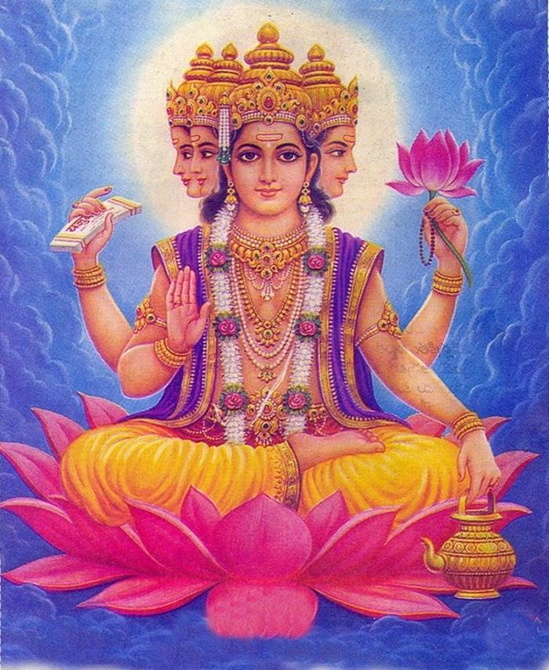  Brahman | 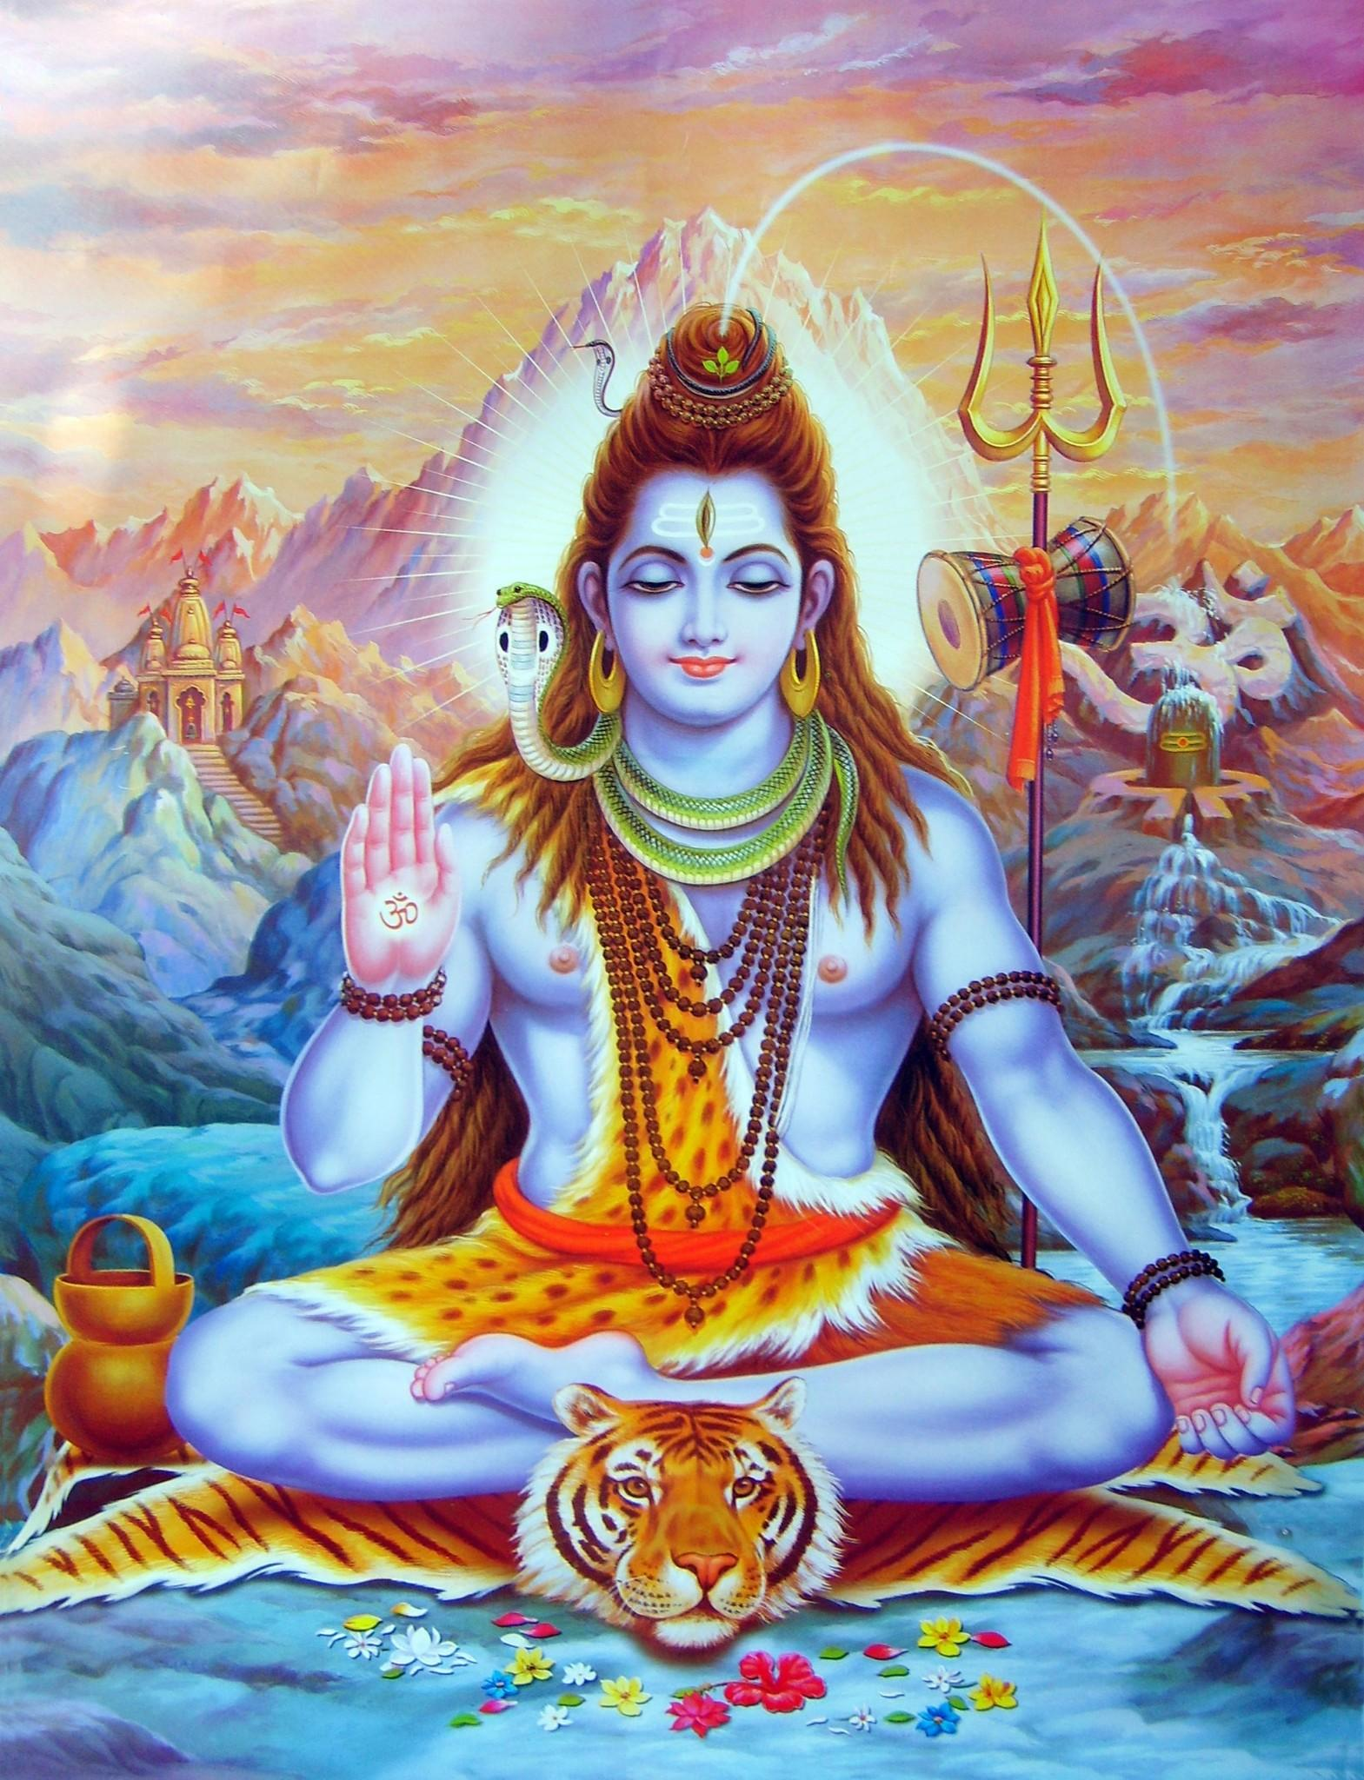  Shiva | 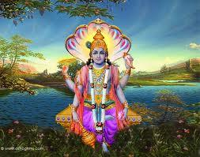  Vishnu

Ideas:
Hindus believe that images reveal more than the written word. Unlike Judaism, Christianity and Islam, which revere their sacred texts as the revealed word of the One God, the Hindus give sacred texts a secondary role and give primary importance to visual resources.

Well Known Deities (pg. 246-247)
- What does the word “iconography” mean?

- Read and complete the “Make it Your Own” activity on pg. 247.

Illustrated Graphic Organizer: The Avatars of Vishnu
- Conduct research using the internet or library resource to complete a graphic organizer that identifies the following information for each of Vishnu’s avatars:
- the name of the avatar
- one thing you discovered about the avatar that interested them
- why the avatar is important for Hindus
- You should include an image of each avatar to illustrate your graphic organizer
* Assessment: Graphic Organizer Rubric

Morality

Think | Pair | Share
FOUR goals you have in life and what you plan to do to reach them (your action plan):  1.  2.  3.  4. |  | Comments and suggestions of how to fine-tune this action plan:

Ideas:
The goal of Hinduism is the liberation from the cycle of rebirth. The Bhagavad Gita, the lord Krishna provides a guide for reaching this goal. This guide describes the three paths to liberation.

CREATE a mind-map below that illustrates and summarizes the information about the three paths of liberation (pg. 248 and 250)

Maranatha: Homework Task
- You are asked to do your own Christian based meditation at home. Maranatha (come lord Jesus come)
- Benedictine monks adapted this practice into a Christian form of prayer known as Contemplative Prayer. It would come to be used by many other Christian groups.
- Guided meditation steps:
- Sit silently to chant maranatha for two minutes on your own, repetitively.
- Relax your body, close your eyes, and focus on your breathing. You should be breathing deeply, slowly and peacefully.
- Repeat your two minutes of chanting the mantra maranatha again.
- You will be required to do a short in class assignment based on your experience.

Daily Meditation: Class practice (bring blanket/pillow if you want)
- We will be learning how to do daily meditation and relaxation techniques in class

The Meaning of Aum
- pg. 249-250
Picture of Aum - notice the three different parts.

Ideas:
Aum is the sound emanating from the universe from the moment of creation to the moment of its destruction. Mystics claim to be able to hear the humming sound of this cosmic vibration. For Hindus, Aum is the sound of the primal energy that brought the universe into being and, therefore, represents the fullness of creation.
The path of devotion in Hinduism has some similarities to Christian practices of praying to Jesus, Mary or other saints to intercede on our behalf to Jesus/God. But there are also alot of differences. Make a mental note of these after reading pg. 250.

Epic Religion Battles: Karma Yoga vs. Christian Service
Q: Is it possible to perform an act of charity without thinking of what we can gain from this act ourselves? Do we somehow expect to be thanked when helping someone through a difficult time? When we give someone a present, do we expect a present in return?

Ideas:
For Hindus, detachment from material things in acts of service or charity is important if they are to accomplish the supreme good they seek. Christians too have encouraged detachment from the things of Earth as a spiritual value. But by calling this detachment charity, Christians add that the motives for giving is the gratitude for the Earth they all have received, and generosity to others for all the gifts they have received from God.

Shared Reflections: Compare Karma Yoga to Christian Service. (handout)

Journal Reflection: Three paths of yoga
Reflect in your journals on the following questions:
- When you think about your life, what are the goals you have for yourself?
- what paths do you see as necessary for reaching those goals?
- what techniques or disciplines are central to each path?
- Who has taught or continues to teach you about these goals, paths and techniques?

Family Life

The following scripture passage provides us of an image of what a Catholic family should be like and helps us to identify our role in our families:

Colossians 3:18-21
“Wives be subject to your husbands, as is fitting in the Lord. Husbands, love your wives and never treat them harshly. Children, obey your parents in everything, for this is your acceptable duty in the Lord. Fathers, do not provoke your children, or they may lose heart.”

Laws of Manu (page 251)
- Roles of men and women within Hindu families.

Gender Roles: Compare and Contrast

- Use the Venn diagram below to compare and contrast the roles of Hindu Men and Women in their own families.

What is POSITIVE about the Hindu model of family?

What is POSITIVE about the Christian model of family?

Negatives (one from each)?

Arranged Marriages

Pros and Cons: Love Marriages
PRO | CON

~ Compare this list with with the list in your textbook on pg. 252-253.

Role Play
- After reading about Arranged Marriages, you will work in groups of three to role play a scenario:
Assume the role of a young Hindu man or woman living in Canada. You have met and fallen in love with a young Canadian person who is not a Hindu, and this person has proposed marriage. Meanwhile, your parents have already decided on an arranged marriage for you to a person you have known since you were a young child. As a Canadian, you have learned to appreciate the Western notion of marriage for love, but as a Hindu, you can appreciate the practice of arranged marriages.
PLAN what you would say to your PARENTS and then ROLE-PLAY the discussion.
(live performance, or filmed)

Make It Personal (pg. 253):
~ Answer below and then discuss with a partner
“Imagine that your parents were arranging marriage for you. How would you feel? Why?”

Interreligious Dialogue: Hinduism and the Catholic Church
- video: Fr. Bede Griffiths

Research and find out 5 things about Gandhi (Mahatma Ghandi)

Film Discussion: Gandhi (handout of discussion questions)

