The Story of Islam - WRST 30

~ The call to prayer (adhan) - listen.
Ideas:
This call to prayer is played 5 times a day. What is your first reaction? What does this practice of calling the community to prayer reveal about Islam?

Al-Fatiha (Qur’an, Sura 1) pg. 186 - read and identify the beliefs expressed in the prayer. List a few of the beliefs below:

-

-

-

Look at the image of the mosque (pg. 186). How is it different for a Catholic church?

- What do Muslims use quotes from the Qur’an to decorate a mosque? (brainstorm reasons)

Journal Reflection:
“ If you were to sum up your belief in God (or someone’s belief in God) into a one or two sentence statement, what would the statement be?”

What I KNOW about Islam | What I WANT to know about Islam | What I DO know about Islam
1.  2.  3.  4.  5. | 1.  2.  3.  4.  5. | 1.  2.  3.  4.  5.

Read Genesis 22:1-19 (Abraham offers Isaac in sacrifice to God) - Jews, Catholics and Muslims all trace their faith back to Abraham...strange!

Read the personal recollection of Alya Ahasan.
Question: “What stand out in this story for you? How is Alya’s story different from yours? If you were writing to Alya, what story would you tell her about a ritual or an experience of fasting?”
Answer (from group ideas):

Work in pairs or small groups (no more than 3) to find out statistics and the demographics pertaining to Muslims in Canada. Find 3 statistics relating to Muslims in Canada. List them below: (handout: Canadian Muslim Demographics)

1.

2.

3.

Media Survey: Jigsaw Activity
- Around the room you will see are several different news stories relating to Islam, Muslims or issues of concern to Muslims in Canada.
- You will need the handout “Media Survey”.
- Once you have read the article, you will return to your home groups and report on what you’ve read.

Reflection Question:
“How does the media affect our understanding of Muslim communities in Canada?”

Timeline Jigsaw:
- Split into your home groups, summarize and create a symbol/image, then get into small groups and share what you know!

1 Mecca at the Time of Muhammad’s Birth | 2 Muhammad’s Early Life | 3 Struggles in Mecca | 4 Hijra: The Return to Mecca
Summary: | Summary: | Summary: | Summary:
Symbol/Image: | Symbol/Image: | Symbol/Image: | Symbol/Image:
Compare and Contrast: Life of Jesus to Life of Muhammad (to be handed in)

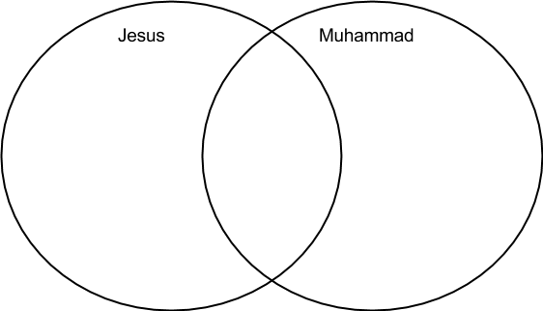

* Can do in partners/small groups
* consider their early life, ministry, gathering followers, encounters with God, low moments and successes.

Visual Character Sketch - The Life of Muhammad
- Using the handout provided (Muhammad’s name in calligraphy in the middle), You will write descriptive words close to Muhammad’s name to illustrate his character and importance.
- Islam forbids the face of Muhammad to be drawn, but permits his face to be represented as holy light.
- You can use the calligraphy pens to write words/descriptors with symbols to represent the events in Muhammad’s life.
(Approx. time for project = 40-50 minutes)

--> What is the role of a prophet?

Ideas:
Judaism, Christianity, and Islam all revere the prophets as great people, called by God, through whom God speaks. For Muslims, Abraham, Moses, and Jesus are all prophets, but what sets Muslims apart is their belief that Muhammad is the last and greatest of all prophets. For Islam, Muhammad is God’s final word.

Project: A Prophetic Message
Time - 40-50 minutes
- Assume the role of a prophet and name four blessings and four warnings (or as the Qur’an says, curses) that God might want to give young people today.
- WRITE a short outline of each blessing and each warning
- Suggest a strategy for delivering the message of each blessing and warning (film, speech, music, etc.). If you decide to use videos or music, be sure to identify which ones you would use.
- Prepare to share your ideas with your group
- Partners & small groups allowed.

Journal Reflection:
- Read Muhammad’s last sermon (pg. 193) and reread his message of justice and equality.
Question:
“ Where in Muhammad’s last sermon do you find something similar to Jesus’s Sermon on the Mount” (if you are unfamiliar, please research this sermon prior to answering the question)

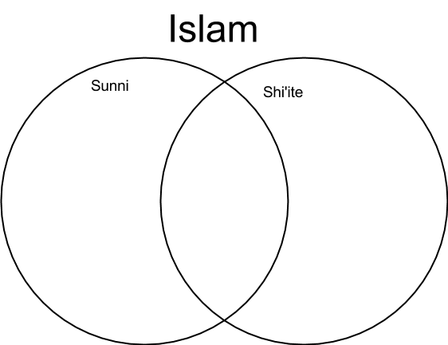

Read pg. 194 - Islam after the death of Muhammad

Rituals and Marking Time

Identify FIVE things and/or people that have guided and strengthened your faith or life.
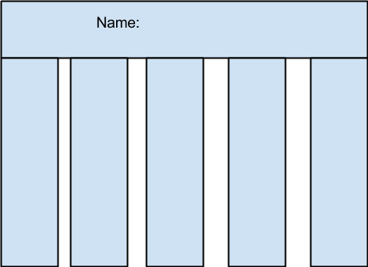

The Five Pillars of Islam

Class Discussion:
- Brainstorm a list of challenges or obstacles Canadian Muslims might face when they try to pray salat five times a day.
- In groups, suggest strategies that schools and workplaces could implement to facilitate salat.
- Be prepared to share with other groups.

What is “Zakat”? (find in your text):

Simulated Journal: Hajj
- Read/review the concept of hajj regarding pilgrimage.
- google search: find out what Christians do on a pilgrimage to Santiago de Compostela.
- Write a SIMULATED journal entry about your hypothetical experience of the hajj.
- Assessment: Journal checklist
Guided Reflection/Meditation:
- Get into a comfortable position. I will read out some questions, and you will internally reflect on them.

What is your impression of hajj?

Make it Your Own (pg. 202) - read in small groups. Make notes beside the images below:

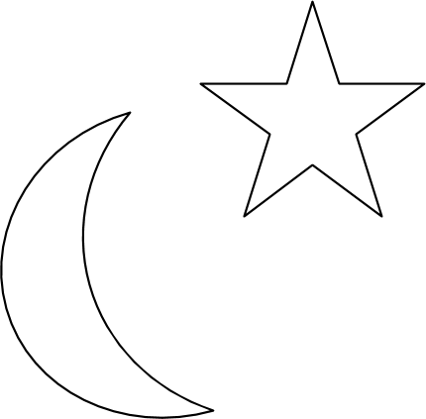

Life Cycle Rituals

Birth
Marriage
Death

Chapter Performance Task: Choose ONE of the options
Time: 1-2 classes

- Option 1 - Compare and Contrast
- REsearch Catholic and Muslim fasting practices
- Summarize and compare information on a t-chart, Venn diagram, or another comparison graphic organizer.
- Information should include the spiritual reason for the first, time in the year when fasting is required, rules regarding food and drink, exceptions to the rules, and activities that accompany fasting, such as prayer and almsgiving. IN a 500-800 word essay, students discuss the practice and importance of fasting for Muslims and Catholics.
- Assessment: Researching and Writing Rubric.

2. A Day of Fast
- Prepare and participate in a day of fast using the Ramadan fast as an example.
- The fast can be limited to the students in the class or extended to anyone in the school who would like to participate.
- In planning the fast, you will need to identify a spiritual purpose or goal for the fast; they develop guidelines and incorporate a time of communal prayer to open and end the fast.
- After the fast, write a reflection “paper” describing the experience and any insights that you have gained regarding the importance of fasting for Muslims and Christians.

Read about Mosques - pg. 186, 200, 201, 205

Sacred Space
Ideas:
A mosque helps to put worshippers in touch with the sacred and brings elievers together as a worshipping community. It creates a sense of belonging within a particular community. It also provides the means and opportunity for members to participate in charitable outreach to the sick and the poor. Can multi-faith chapels do the same in public spaces?

ASSIGNMENT: Multi-Faith Chapel Design
- Imagine that you have been invited to create a space within a public building like an airport, a shopping mall, or a retirement residence that select the building in which they will build their multi-faith chapel and brainstorm the features such a gathering place would contain.
- List each feature on chart paper, providing an explanation for why each was included.
- In your group, draw a floor plan for the space, including special features such as wall decor, sacred objects or furnishings.
- When the plan is complete, groups will post their work and move around the room to view the designs of the other groups. Using sticky notes, students comment on the features they like in each design.
* Assessment: Complete Group-Work Self-Assessment

Central Beliefs
Psalm 17:7-11.
Ideas:
Jews, Catholics and Muslims all consider their sacred books as the word of the Lord, God, and Allah, respectively. All three religions treat their sacred books with great respect. The teachings of the Qur’an are the very heart and soul of Muslim life.

Read pg. 208-209. Summarize below:
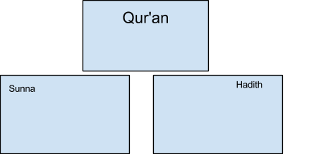

Read Tawhid: The Unity of God (pg. 209)
~ With a partner or individually, generate a list of names for God based on your personal understanding of God’s attributes:

99 Names for Allah:
Ideas:
In Muslim countries, such as Indonesia or Malaysia, Catholcs use the word Allah for God. In the Catholic tradition the names and images for God taken from the Old Testament have been applied to JEsus and have taken on a new meaning.

Read Isaiah 9:6-9 as an example.

A is for Allah - music video by Youssef Islam (formerly Cat Stevens)
This video confirms these things that I know about Islam...
This video tells me these new things about Islam...
This video makes me wonder these things about Islam...

Jihad: Developing a clear understanding
Read: “A Closer Look” pg. 211

jihad is....

Two ways that jihad is interpreted are....
1.

2.

Research: (hand in - 13 marks total) /13
- In partners, conduct and internet research by selecting an English newspaper with a search function on the website and enter the term “jihad” in the search field.
- Find and summarize 10 different articles, placing the summary in the appropraite column of the graphic organizer below.
- Respond the the questions below the T-chart.

Jihad: Holy War | Jihad: Internal Struggle to Obey God’s Will

Questions: /6 marks
1. What image of Islam does your research support?

2. What are the implications of your findings?

3. Can violence be seen as a necessary and just action when viewed through the eyes of one committed to do the will of God?

Read and Discuss: pg. 211-212
Consider - What are the similarities between how Christians and Muslims view Jesus and Mary?
Discussion Points:

Read Sufism and the profile of Rab’ia (pg. 212-213) with a partner. Discuss interesting points.

Sufi Mystics: Read and make point form notes below -

Centering prayer and meditation: Guided meditation “A New Jerusalem”
Ideas:
John Main, a Benedictine priest, was inspired by a Hindu teacher and formed a method of Christian meditation that renewed the ancient Christian practice of meditation for people today. Later he formed a Christian meditation movement that has since spread throughout the world. His meditations all begin with what is known as a centering prayer (prayer intended to help the person meditating focus on God’s presence)

- What effect did the centering prayer have on how you listened to the words of the meditation?

- Was it a good experience you would like to repeat? YES/NO

- How does this way of praying compare to the dance of the Whirling Dervishes?

Morality
Ideas:
There are many moments in our lives when we feel torn between two choices: what we WANT to do and what we SHOULD do (between staying at or leaving a party where there is illegal activity, between keeping a curfew or staying out all night, between doing the work or cheating on an assignment). These moral decisions create tension or an internal conflict and sometimes we need advice before we can make the right decision.

Reflect on the following questions (5 minutes)

1. When you face moral tensions, do you turn only to your feelings to decide what to do or do you also listen to something else?

2. What is the other voice and how do you decide between that voice and your feelings?

Sharia Law
Read pg. 214-215

Three-Step Interview
- Get into groups of 4. Pair off.
- Discuss and decide upon the most important idea of the section on Shariah and discuss any questions either of you have about this section.
- Get back into big group of 4 and share.

Journal Reflection:
Question - “What are some of the guiding principles (Christian or not) that have guided you through making tough decisions? Give an example from your life. Were there others who guided you at this time? Who and how?”

Fatwas
Read pg. 216
Discussion:
- WHY would a religion find it necessary to have individuals responsible for this kind of decision - or law-making
- Issues today: cyber-bullying, Internet pornography, underage drug/alcohol use, genetically modified foods/crops, stem cell research. Can you formulate some more guidelines on one of these issues (with a partner beside you)?

Sharia Law in Canada: Reflecting on Media Stories
- Students will work independently to examine and critique several media stories about Islam’s right to practice sharia law in Canada.
- Use your handout “Reflecting on Media Stories” to summarize the stories/articles, identifying the main pros and cons and noting any bias or prejudice.
- In the final column of your chart, write a personal comment expressing yourreaction to this article.
- In small groups, share your reactions to the various news stories you’ve collected.
* Assessment: Self-Reflection Tool

Mini-Debate: How far should Canada go?
- How far should Canada go to accomodate the culture and traditions of immigrants? SHould some elements of sharia law be allowed in Canada? Why or why not?”
- In a small group, you will debate and discuss this idea from BOTH sides of the argument (using the outline of Academic Discussion) and come to a conclusion through consensus
- Assessment: Group Work Self-Assessment

****HOMEWORK: Bring in an object from home that best reflects life in your family (football, board game, pictures of vacation or person, etc.) ****

Family Life
Share in small groups about the object you have brought to class. Make sure to tell the others how this reflects your family life.

Read pg. 216-217: Gender Roles in Muslim Families

Compare and Contrast: Muslim Family Life to MY Family Life

Assignment: Simulated Journal
Directions -
- Based on what you have learned so far about life in a Muslim family, students imagine life in a Muslim household.
- Create five journal entries that a Muslim youth might write about different aspects of his or her family life.
- Assessment: Journal checklist

Opposing Views: Opinion/Debate
- Read pg. 218 “clothing” and about Asmahan Mansour.

BRAINSTORM a list of arguments for and against the wearing of the hijab in particular situations. (school, work, sports, airports, etc.)
For | Against

Ideas:
In the past, some Canadian schools have said that head coverings such as the hijab do not conform to the school’s dress code and must not be worn in school.

In your groups you will be brainstorming a list of arguments for wearing the hijab without restrictions OR wearing the hijab with restrictions (stating which situations are okay and which aren’t)

MY GROUP: Restrictions/No Restriction
My Notes:

*Group work Self-Assessment

Media’s Role in Western Understanding of Islam: Discussion
Ideas:
In many of the issues we see in newspapers relating to family life and gender roles in Muslim families are cultural, not necessarily religious. For example, the Qur’an teaches about equality for women, yet it is not always practices in some Muslim cultures. Many cultures throughout history have used religion to abuse power and fuel pre-existing prejudices and stereotypes. It is important to be sensitive to these abused and realize that it is not always a reflection of that faith, but cultural distortions.

Article Reading Session: in small groups, move from article to article and read over it together.

Questions (to answer as a group):

“Does the Media help to sustain the stereotypes associated with Muslim people?”

“Do you think it is right for Muslim women to have to wear a hijab?”

“Why might it be difficult for Muslim youth to practice their faith in Canadian society?”

* If time, roundtable discussion (with exit card/questions)

--> Women and the hijab: opinion paper/essay

--> Islam’s approach to sexuality: discussion points (CCC 2231)

Interreligious Dialogue
Matthew 25:1-13
Restate this scripture in your OWN words:

“Keep your Heart Awake” by Rumi (pg. 227)
Restate the message of this poem in your OWN words:

Question: Are there any similarities in these two messages? What do these similarities tell you about Catholic and Muslim beliefs?

Islam and the Catholic Church (pg. 223-227)
Positive factors affecting Catholic-Muslim relationship | Negative factors affecting Catholic-Muslim relationship
Video: The Imam and the Pastor
Ideas:
This video explores the possibility of peace between Muslims and Catholics in Nigeria. Pastor James Wuye and Imam Muhammad Ashafa, once bitter enemies, now co-direct the Muslim-Christian Interfaith Mediation Center in their city to resolve conflicts across Nigeria. This film offers a message of hope for peace in the world. View the film and then respond to the questions on the handout. Then, use the film to write a film review for a local newspaper using your answers from the handout as a guide.

- Handout: Video Review - Imam and the Pastor
- Assessment: Research and Writing Rubric

Evaluating Different Perspectives
Skill Focus pg. 226 - Analyzing Different Perspectives

Question:
“In light of what you have learned about Catholic-Muslim relationships, how can working together for justice be a way to strengthen Christian-Muslim relationships in Canada?”

